

**Hospital Management System**

Ahmad Arafat

**Contents**

**1 - Introduction: 7**

**2 - The Problem: 7**

**3 - Explain The Code: 8**

**3.1 - Struct Address 8**

**3.2 - Class Nurse 9**

**3.2.1 - Private 9**

**3.2.2 - Public 10**

**3.2.2.1 - Pointers 10**

**3.2.2.2 - Create The Nurse List 10**

**3.2.2.3 - Input the Data 11**

**3.2.2.4 - Print the Nurse List 13**

**3.2.2.5 - Edit the Nurse Information 14**

**3.2.2.6 - Delete Nurse 15**

**3.3 - Class Stack 16**

**3.3.1 - Private 16**

**3.3.2 - Public 17**

**3.3.2.1 - Pointers 17**

**3.3.2.2 - Constructor 17**

**3.3.2.3 - Push 18**

**3.3.2.4 - Pop 19**

**3.3.2.5 - Display 20**

**3.4 - Class Queue 21**

**3.4.1 - Private 21**

**3.4.2 - Public 22**

**3.4.2.1 - Pointers 22**

**3.4.2.2 - Constructor 22**

**3.4.2.3 – Enqueue 23**

**3.4.2.4 - Dequeue 24**

**3.4.2.5 - Display 25**

**3.5 - Class Doctor 26**

**3.5.1 - Private 26**

**3.5.2 – Public 27**

**3.5.2.1 - Pointers 27**

**3.5.2.2 - Constructor 28**

**3.5.2.2 - Create And Add Doctors 28**

**3.5.2.3 - Input The Data 30**

**3.5.2.4 - Print The Doctor List 31**

**3.5.2.5 - Edit Doctor Information 32**

**3.5.2.6 - Delete Doctor 33**

**3.5.2.7 - Print Doctor Stack 34**

**3.6 - Class Patient 35**

**3.6.1 - Private 35**

**3.6.2 - Public 36**

**3.6.2.1 - Pointers 36**

**3.6.2.2 - Constructor 36**

**3.6.2.3 - Create And Add Patient 37**

**3.6.2.4 - Input The Data 38**

**3.6.2.5 - Print The Patient List 39**

**3.6.2.6 - Edit Patient List 40**

**3.6.2.7 - Delete Patient 41**

**3.7 - Class Visitor 42**

**3.7.1 - Private 42**

**3.7.2 Public 43**

**3.7.2.1 - Constructor 43**

**3.7.2.2 - Insert 44**

**3.7.2.3 - InsertRec 45**

**3.7.2.4 - Printing Functions 46**

**3.7.2.5 - Retrieve Method 47**

**3.7.2.5 - Print Hash Table 49**

**3.8 - Binary Search 50**

**Conclusion 51**

Figure 1 - Address - 8

Figure 2 - Nurse Private - 9

Figure 3 - Pointers - 10

Figure 4 - Create List of Nurse - 10

Figure 5 - Input the Data 11

Figure 6 - Print Nurse List – 13

Figure 7 - Edit Nurse Information - 14

Figure 8 - Delete Nurse - 15

Figure 9 - Stack Private - 16

Figure 10 - Pointers - 17

Figure 11 – Constructor - 17

Figure 12 - Push - 18

Figure 13 - Pop - 19

Figure 14 - Display - 20

Figure 15 - Class Queue - 21

Figure 16 - Pointers - 22

Figure 17 - Enqueue - 23

Figure 18 - Dequeue - 24

Figure 19 - Display - 25

Figure 20 - Class Doctor - 26

Figure 21- Pointers - 27

Figure 22 - Constructor - 28

Figure 23 - Create and Add Doctor - 28

Figure 24 - Input the Data - 30

Figure 25 - Print Doctor List - 31

Figure 26 - Edit Doctor Information - 32

Figure 27 - Delete Doctor - 33

Figure 28 - Print Doctor Stack - 34

Figure 29 - Class Patient - 35

Figure 30 - Pointers - 36

Figure 31 - Constructor - 36

Figure 32 - Create and Add Patient - 37

Figure 33 - Input the Data - 38

Figure 34 - Print List Patient - 39

Figure 35 - Edit Patient Information - 40

Figure 36 - Delete Patient - 41

Figure 37 - Class Visitor - 42

Figure 38 - Constructor - 43

Figure 39 - Insert - 44

Figure 40 - InsertRec - 45

Figure 41- Printing Function - 46

Figure 42 - Retrieve Method - 47

Figure 43 - Print Hash Table - 49

Figure 44 - Binary Search - 50

# 1 - Introduction:

The efficient running of hospitals is very important for achieving best patient care as well as effective use of resources and organization functionality within the current healthcare setting. It is more necessary now than ever before because healthcare delivery has become more complex. We talked about Hospital Management Systems (HMS). Hospital Management Systems (HMS) have come to offer an integrated approach for proceeding through these systems.

# **2 - The Problem:**

How Can Link All Class and Struct and Linked List and Stack and Queue in Programing and Make It Is a Special System.

# 3 - Explain The Code**:**

## **3.1 - Struct Address**

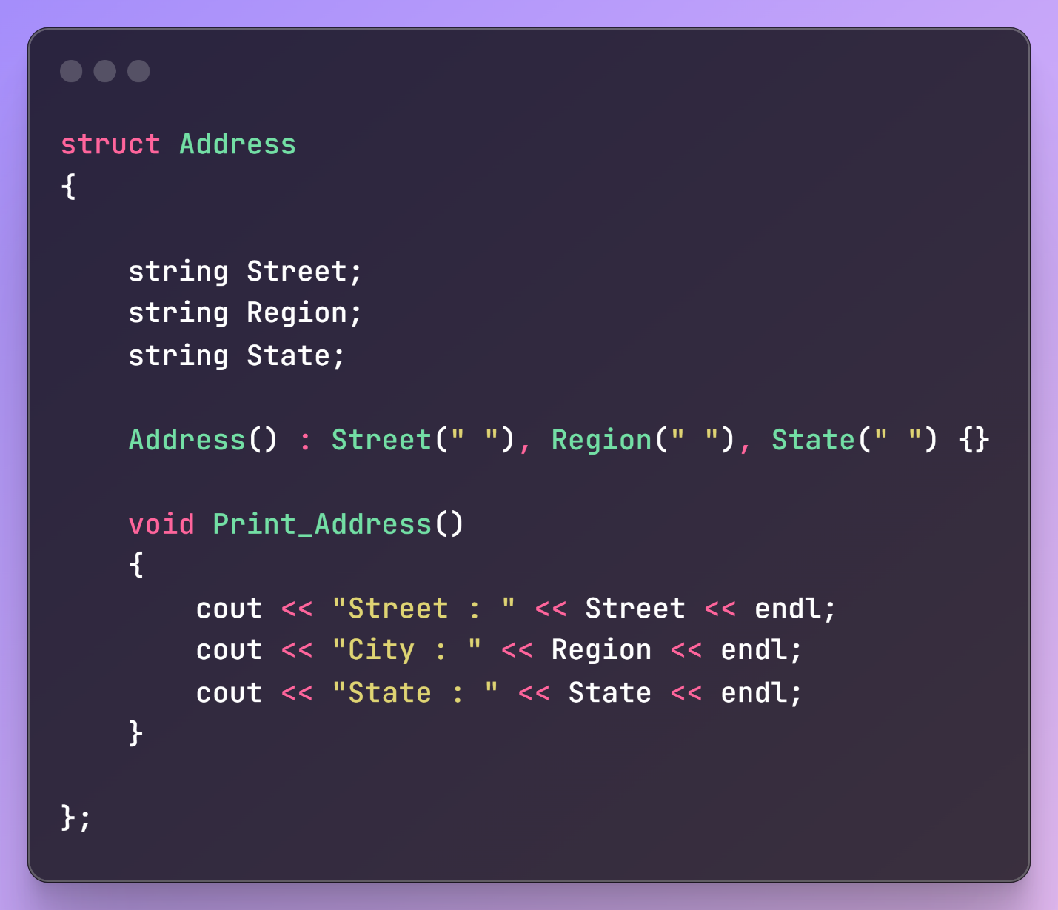

Figure 1 - Address -

The Structure Have Three Variable Street, Region and State, Constructor to Set the Empty Value of Address and Function to Print the Data of Address.

## **3.2 - Class Nurse**

### **3.2.1 - Private**

Figure 2 - Nurse Private -

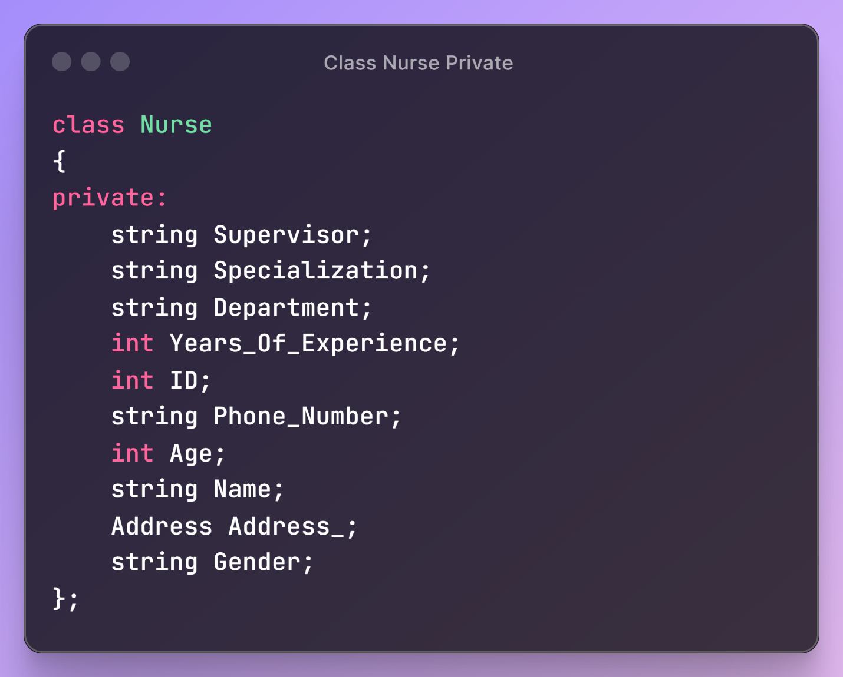

The Nurse Class is Designed to Encapsulate a Variety of Data About a Nurse, Including Personal, Professional, and Contact Information, Along with Their Address. The Class Contains Both Private Data Members and Public Methods.

### **3.2.2 - Public**

#### **3.2.2.1 - Pointers**

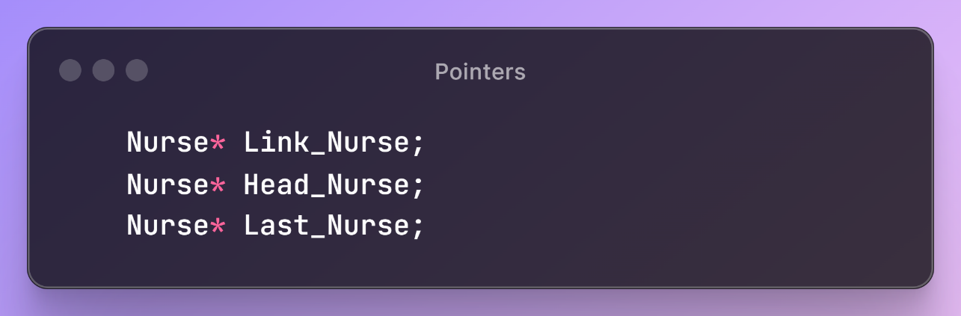

Figure 3 - Pointers -

Will Declare Three Pointer of Class Nurse to Used it To Create the List of Nurse.

#### **3.2.2.2 - Create The Nurse List**

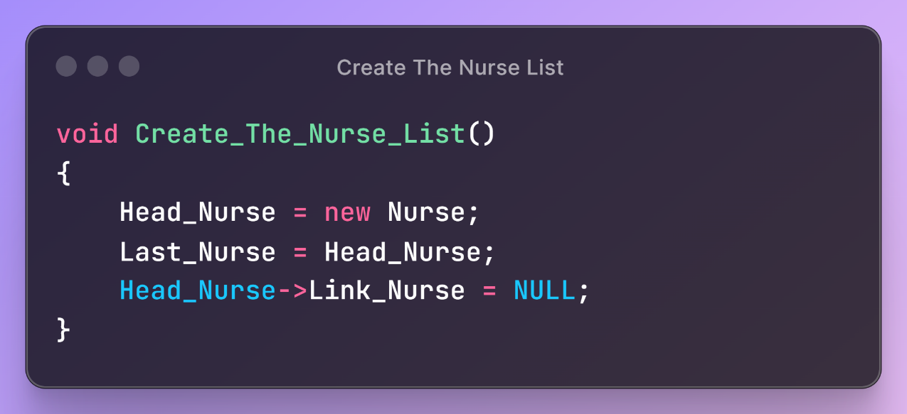

Figure 4 - Create List of Nurse -

Will Create One Node of List and More in Add Nurses.

#### **3.2.2.3 - Input the Data**

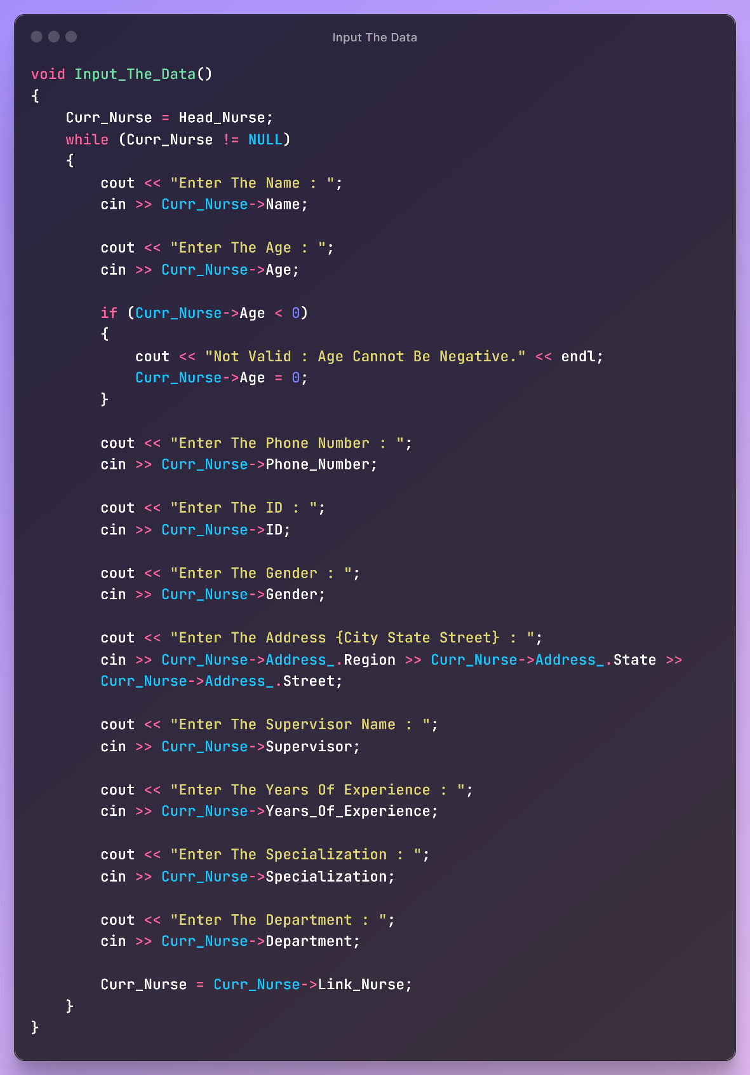

Figure 5 - Input the Data

The Input_The_Data function collects and inputs details about a nurse into a Nurse structure. It prompts the user for the nurse's name, age, phone number, ID, gender, address, supervisor's name, years of experience, specialization, and department, storing each piece of information in the respective fields of the structure. If the entered age is negative, it displays an error message and sets the age to zero. The function uses standard input and output commands for data entry and feedback.

#### **3.2.2.4 - Print the Nurse List**

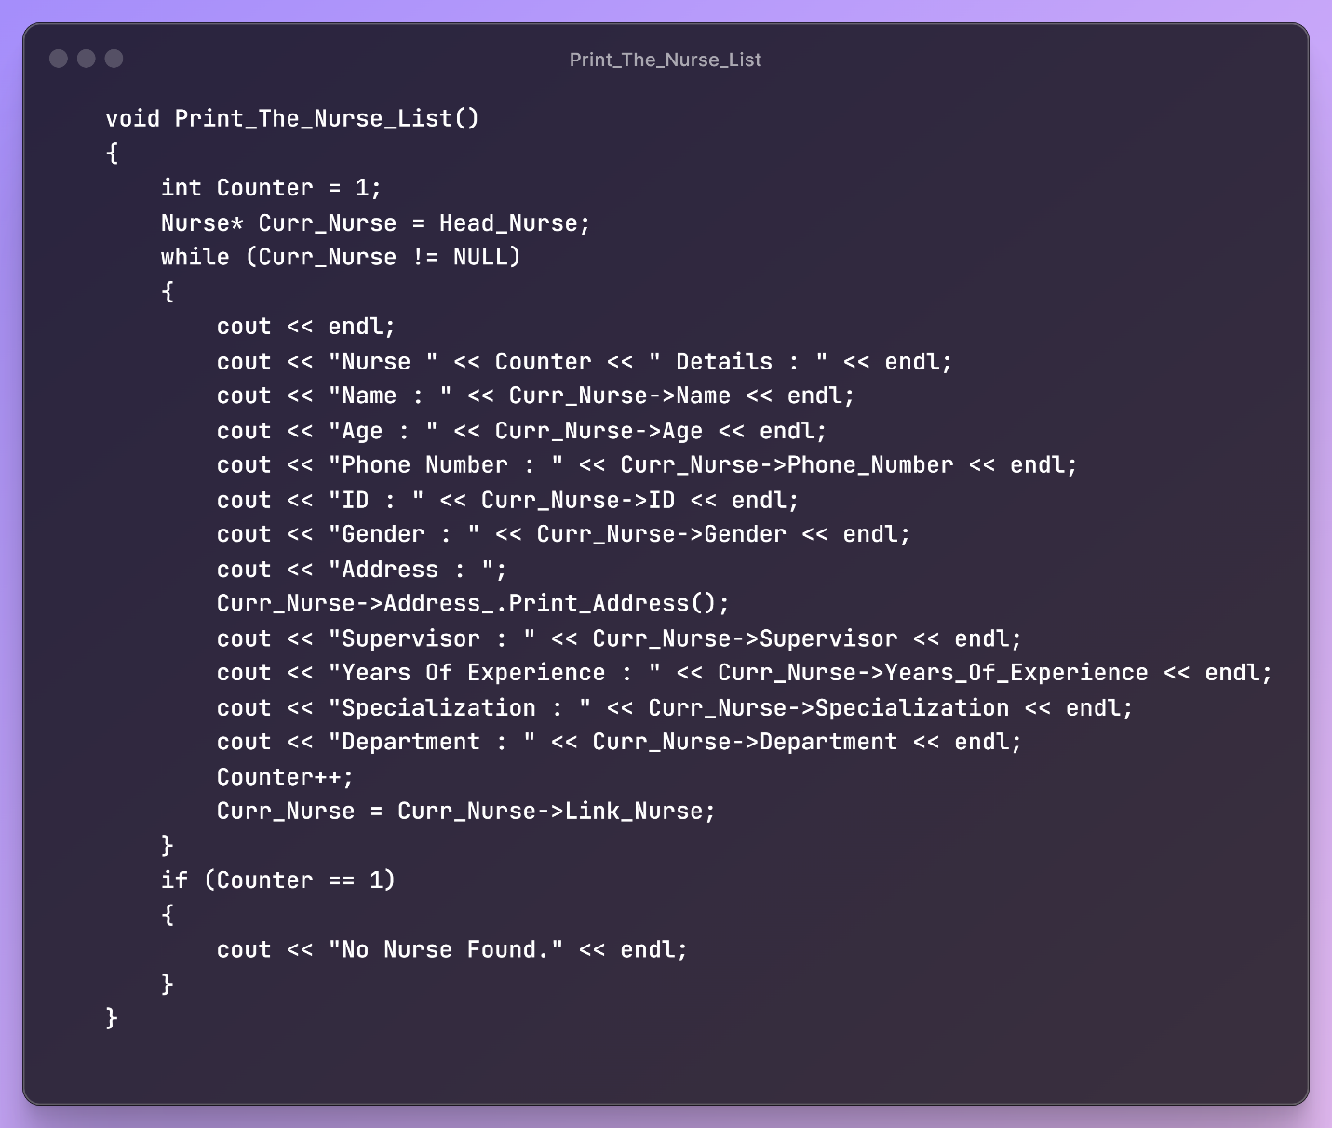

Figure 6 - Print Nurse List –

The Print_The_Nurse_List function displays information about nurses from a linked list. It prints details like the name and age for each nurse. If no nurses are found, it outputs "No Nurse Found.”

#### **3.2.2.5 - Edit the Nurse Information**

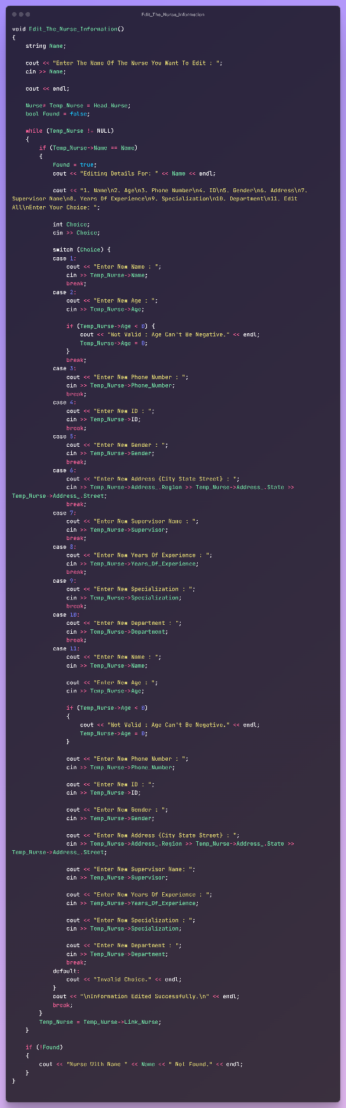

Figure 7 - Edit Nurse Information -

The function Edit_The_Nurse_Information allows for editing the details of a nurse in a linked list by first asking the user to enter the name of the nurse. It then searches through the list to find a matching nurse. If found, it displays various options for the user to edit specific attributes of the nurse or all attributes at once. The user selects, inputs the new information, and the function updates the nurse's details accordingly. If the nurse is not found, it notifies the user. The function ensures data integrity by validating input for the age to prevent negative values.

#### **3.2.2.6 - Delete Nurse**

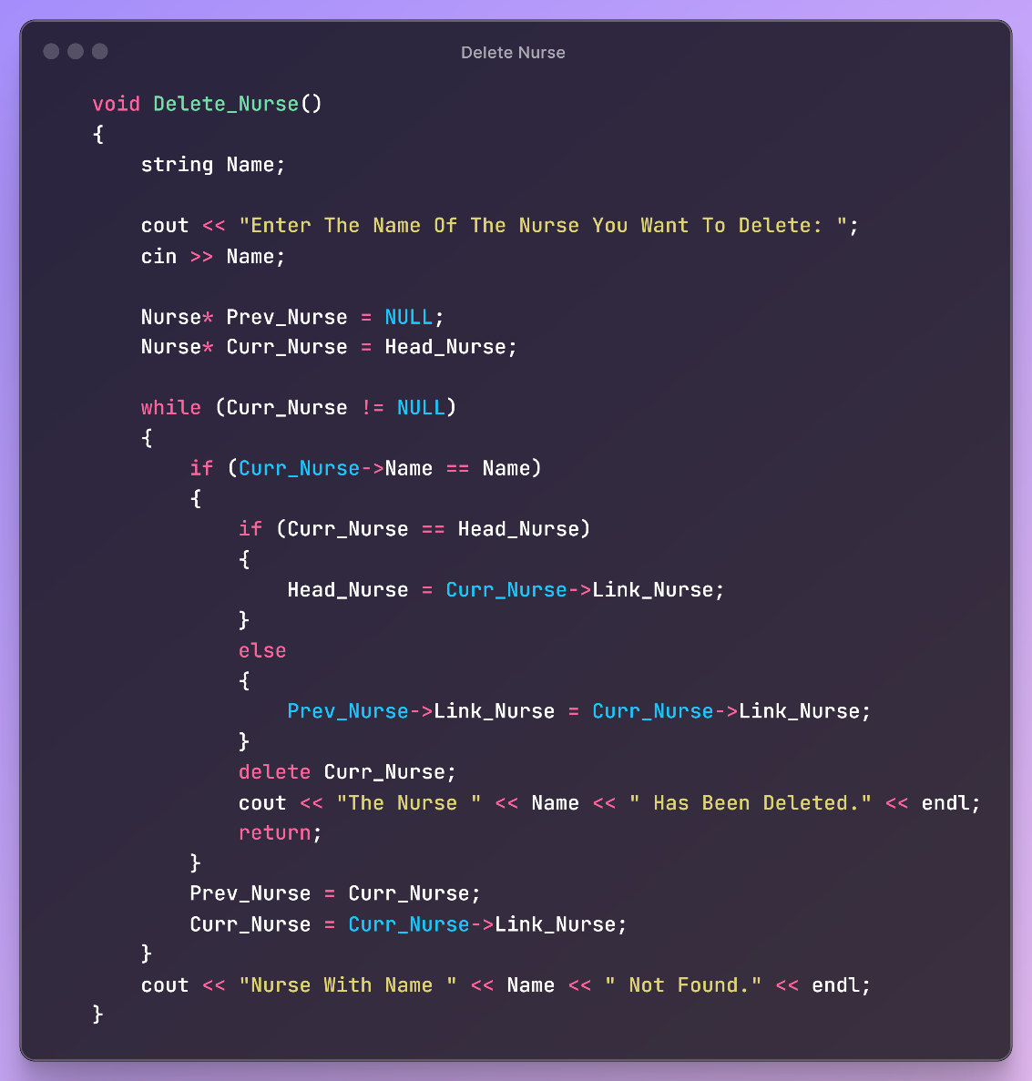

Figure 8 - Delete Nurse -

The Delete_Nurse function removes a nurse from a linked list by name. If found, the nurse is deleted and the list is updated; if not, a message indicates the nurse was not found.

## **3.3 - Class Stack**

### **3.3.1 - Private**

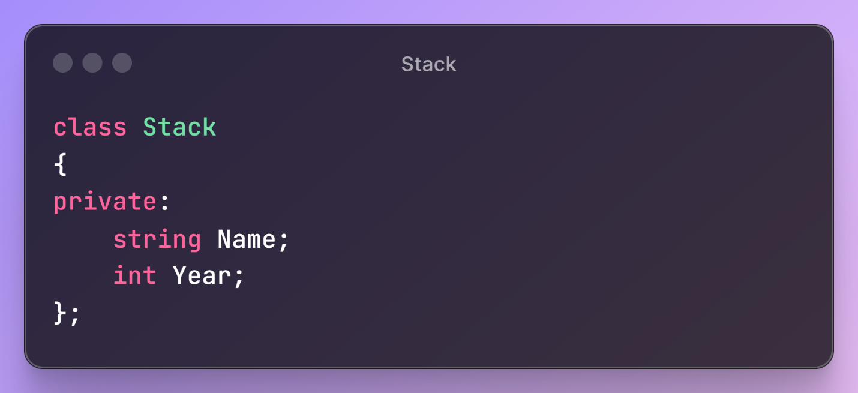

Figure 9 - Stack Private -

The Stack class in C++ contains two private data members: Name (a string) and Year (an integer). Methods would be needed to access and modify these private members since they can't be accessed directly from outside the class.

### **3.3.2 - Public**

#### **3.3.2.1 - Pointers**

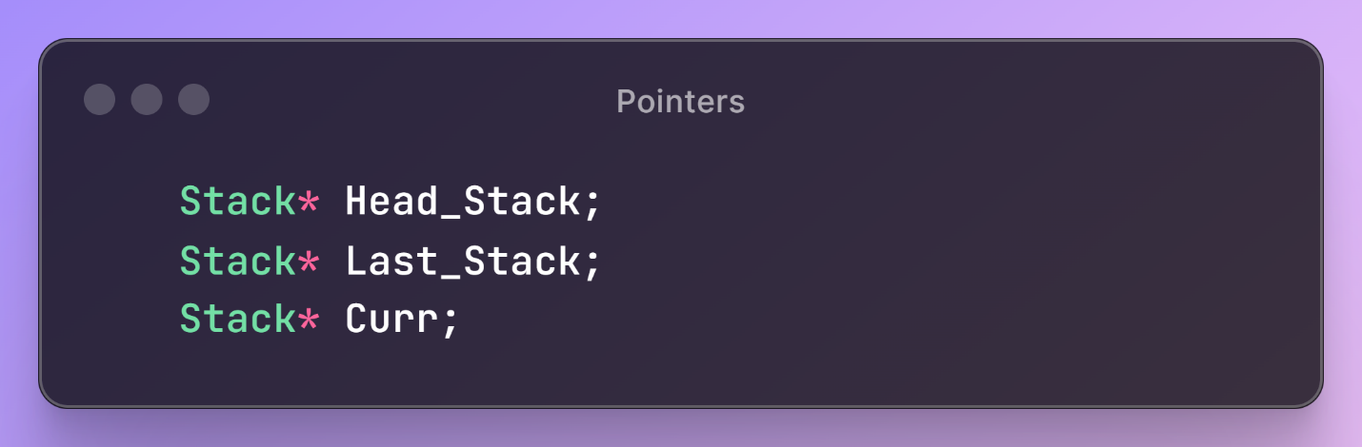

Figure 10 - Pointers -

Will Declare Three Pointer of Class Stack to Used it To Create the Stack.

#### **3.3.2.2 - Constructor**

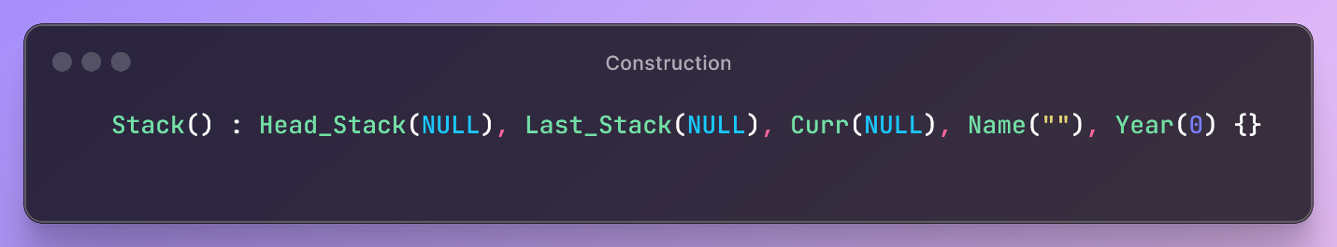

Figure 11 – Constructor -

Default Construction.

#### **3.3.2.3 - Push**

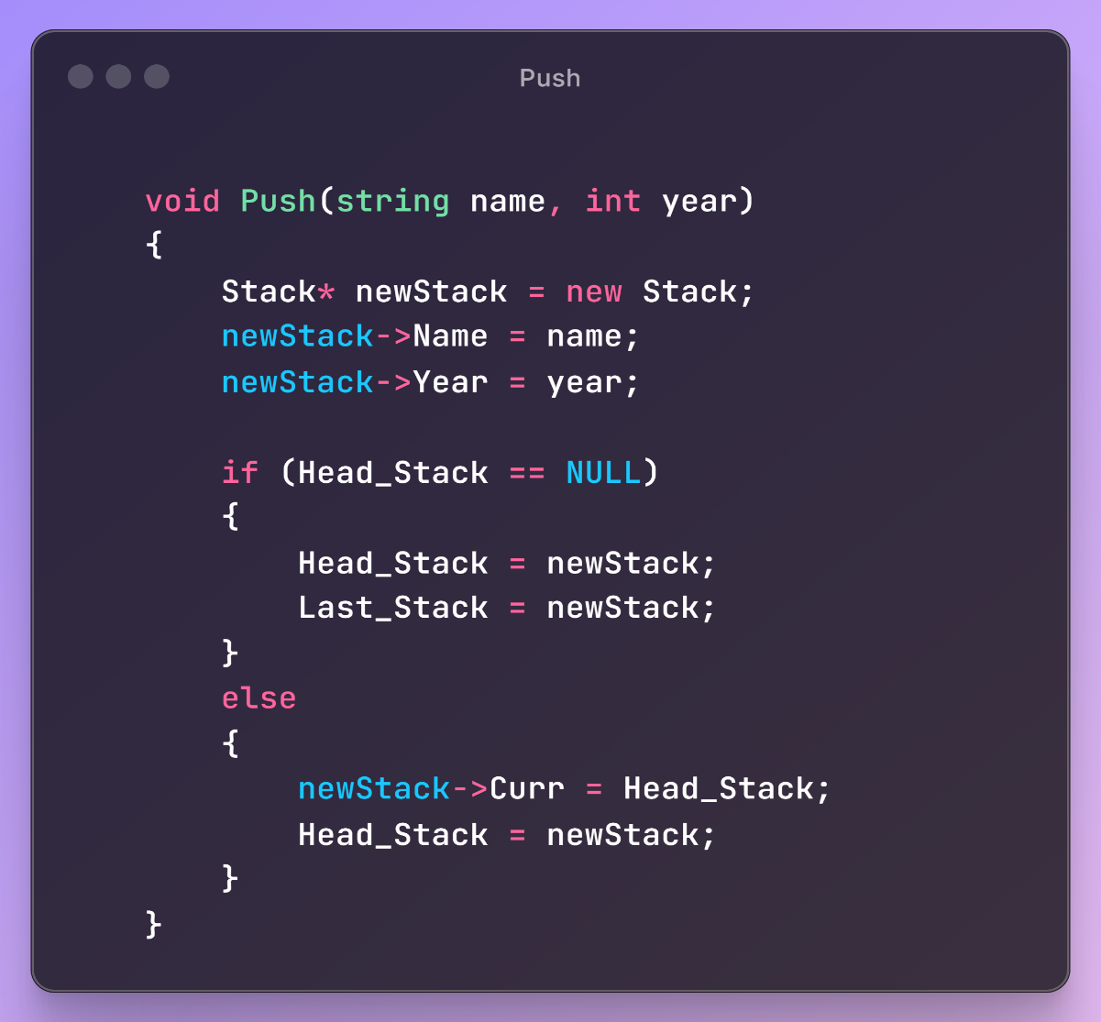

Figure 12 - Push -

The Push function adds a new Stack object to the top of a stack implemented as a linked list. It creates a new node with the given name and year, checks if the stack is empty, and either initializes

the stack with this node or inserts it at the beginning, updating Head_Stack to this new node.

#### **3.3.2.4 - Pop**

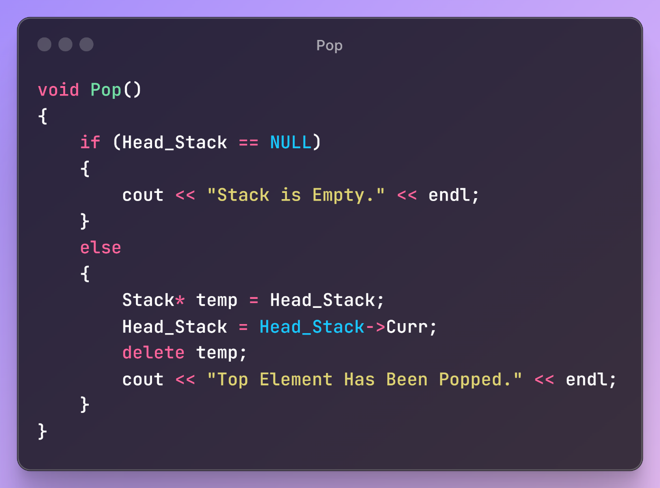

Figure 13 - Pop -

The Pop function removes the top element from a stack, updating the head of the linked list to the next node and deleting the old head. If the stack is empty, it outputs a message indicating so.

#### **3.3.2.5 - Display**

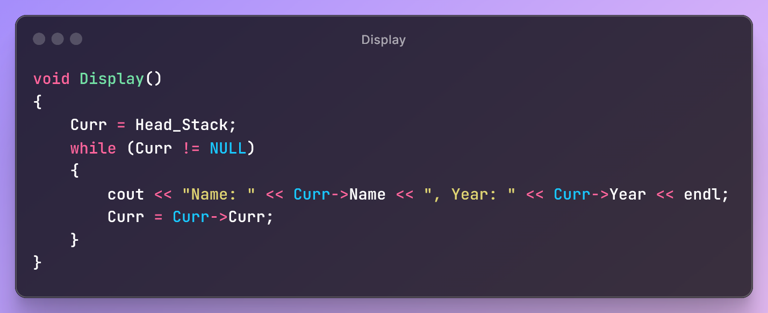

Figure 14 - Display -

The Display function is used to print all the elements in the stack, showing each element's Name and Year. It iterates through the stack from the top to the bottom, using a pointer Curr that starts at Head_Stack and traverses through each node until it reaches NULL, indicating the end of the stack. For each element, it prints the Name and Year before moving to the next node in the stack.

## **3.4 - Class Queue**

### **3.4.1 - Private**

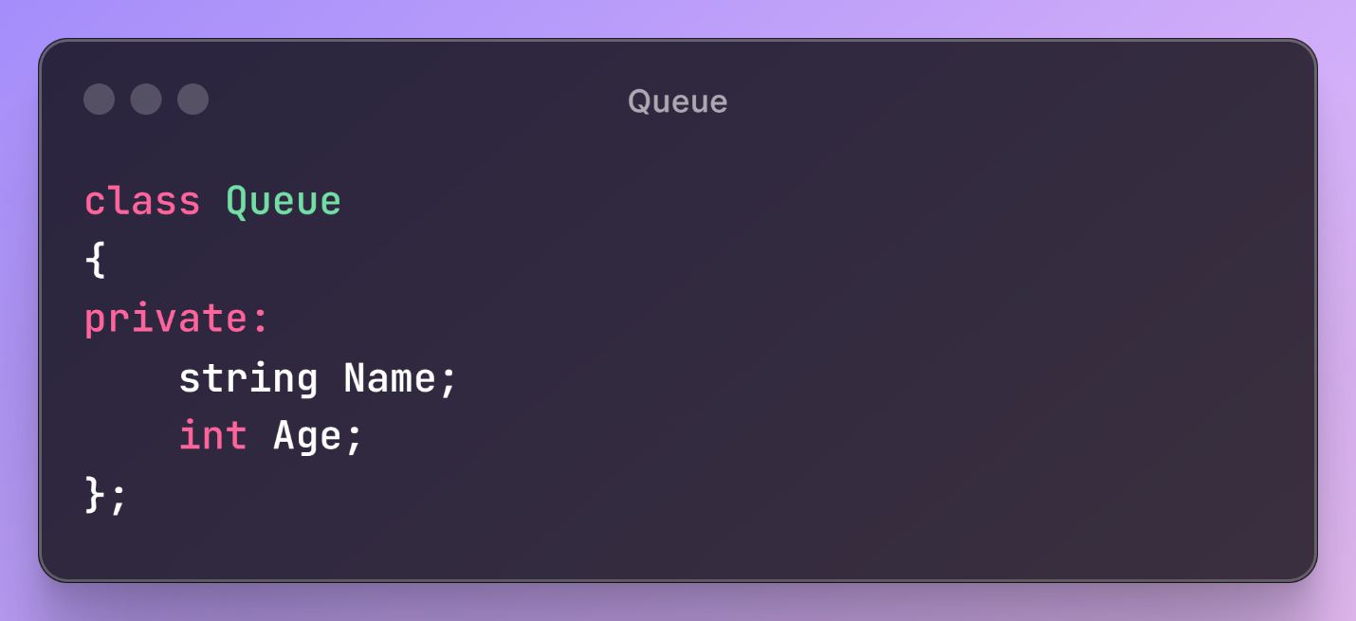

Figure 15 - Class Queue -

The Queue class contains two private attributes: Name, a string, and Age, an integer. These members are not accessible directly outside the class, promoting data encapsulation

### **3.4.2 - Public**

#### **3.4.2.1 - Pointers**

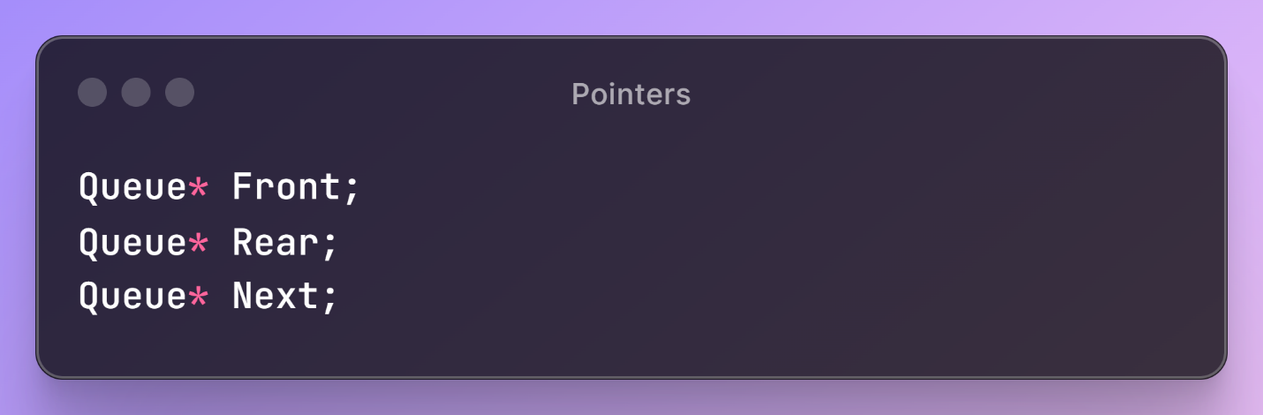

Figure 16 - Pointers -

The pointers Front, Rear, and Next in the Queue class help manage a queue implemented as a queue. Front points to the first item, Rear points to the last item, and Next is used in individual nodes to point to the next item in the queue.

#### **3.4.2.2 - Constructor**

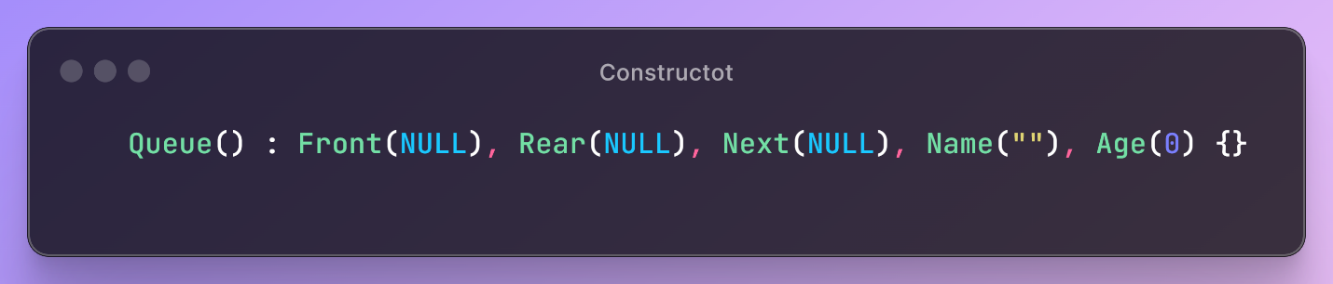

Default Constructor.

#### **3.4.2.3 – Enqueue**

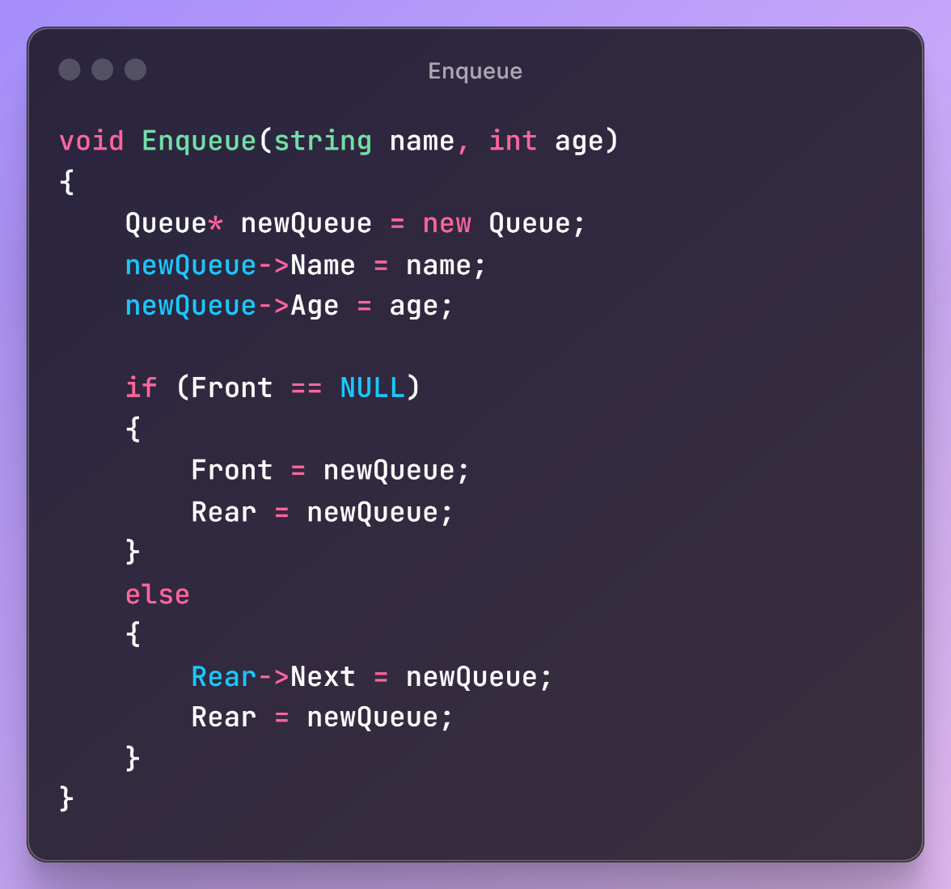

Figure 17 - Enqueue -

The Enqueue function adds a new element to the end of a queue. It creates a new Queue object with specified name and age, checks if the queue is empty, and if so, sets both Front and Rear to this new object. If the queue is not empty, it adds the new object to the end and updates the Rear pointer.

#### **3.4.2.4 - Dequeue**

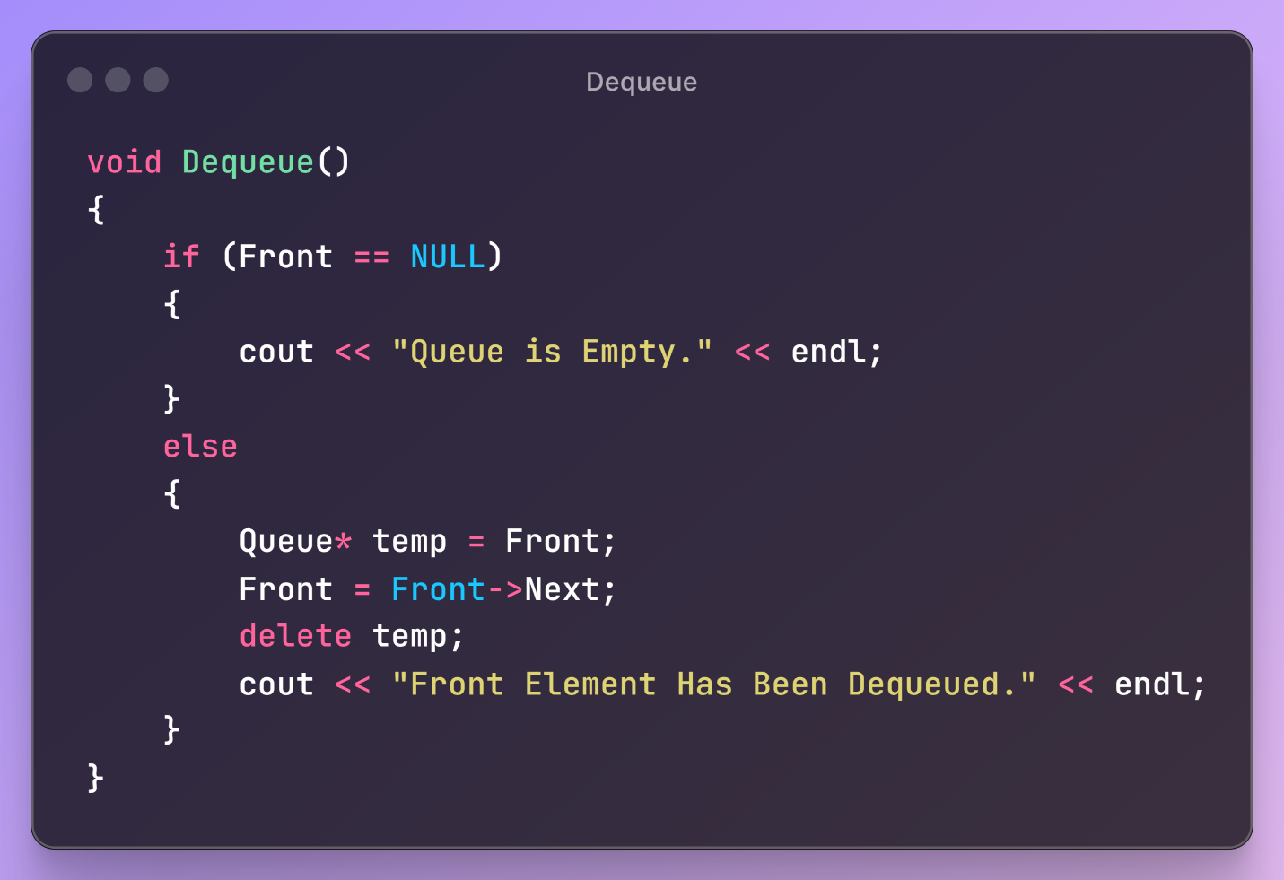

Figure 18 - Dequeue -

The Dequeue function removes the front element from a queue. It first checks if the queue is empty and displays a message if it is. If not, it deletes the front element, shifts the Front pointer to the next element, and confirms the removal with a message.

#### **3.4.2.5 - Display**

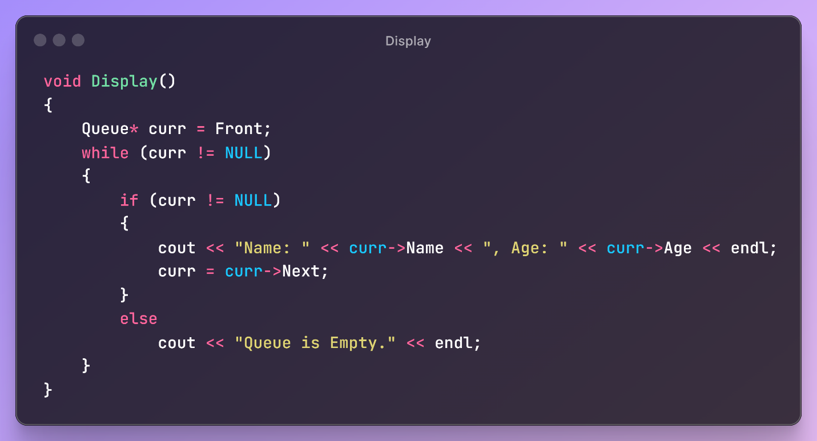

Figure 19 - Display -

The Display function iterates through a queue and prints the Name and Age of each element, starting from the front until it reaches the end.

## **3.5 - Class Doctor**

### **3.5.1 - Private**

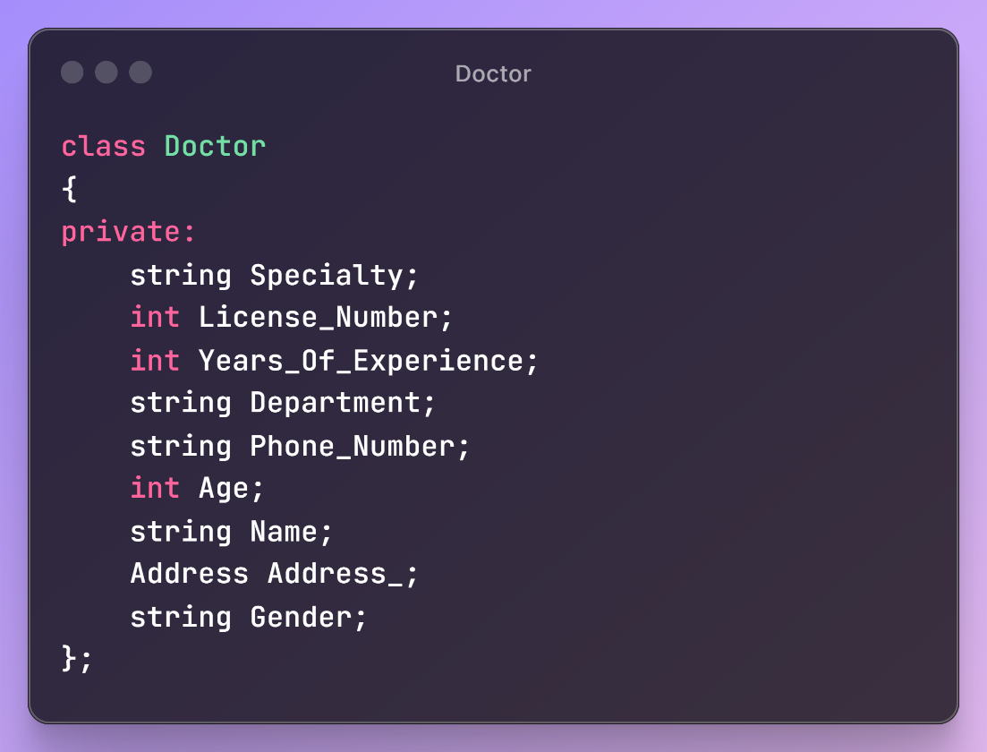

Figure 20 - Class Doctor -

The Doctor class encapsulates attributes of a doctor, including specialty, license number, years of experience, department, phone number, age, name, address, and gender. These attributes are stored as private members, ensuring they can only be accessed and modified through the class's public methods which help maintain encapsulation.

### **3.5.2 – Public**

#### **3.5.2.1 - Pointers**

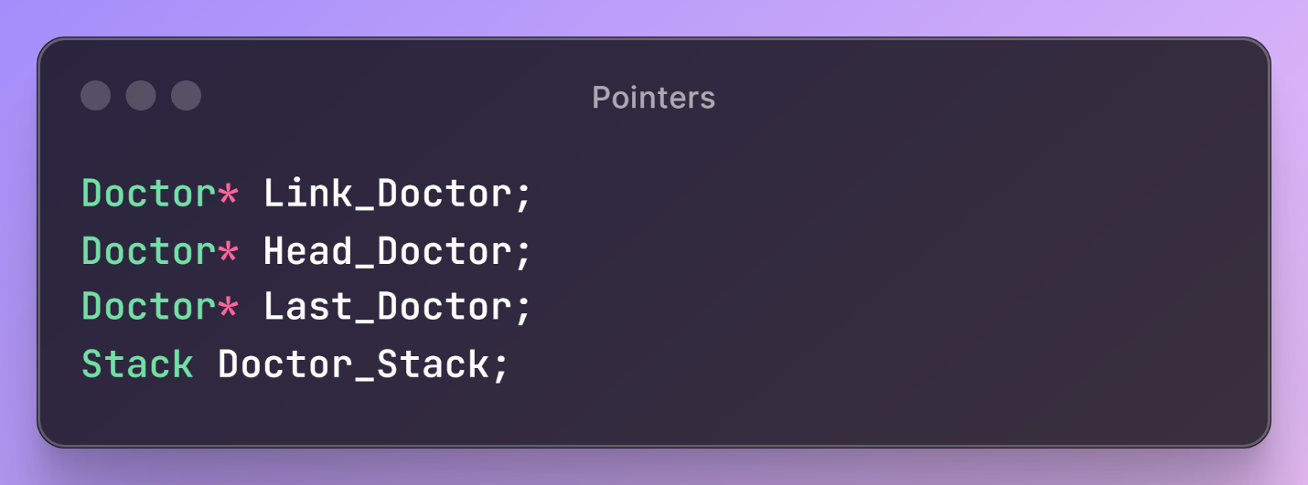

Figure 21- Pointers -

The variables Link_Doctor, Head_Doctor, and Last_Doctor are pointers used to manage a linked list of doctor objects, where Head_Doctor points to the first doctor, Last_Doctor to the last, and Link_Doctor connects each doctor to the next. Doctor_Stack is a Stack object potentially used for storing Doctor data in a last-in-first-out (LIFO) manner.

#### **3.5.2.2 - Constructor**

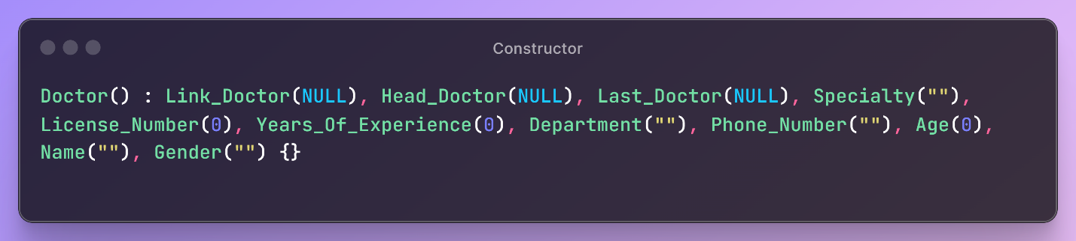

Figure 22 - Constructor -

Default Constructor.

#### **3.5.2.2 - Create And Add Doctors**

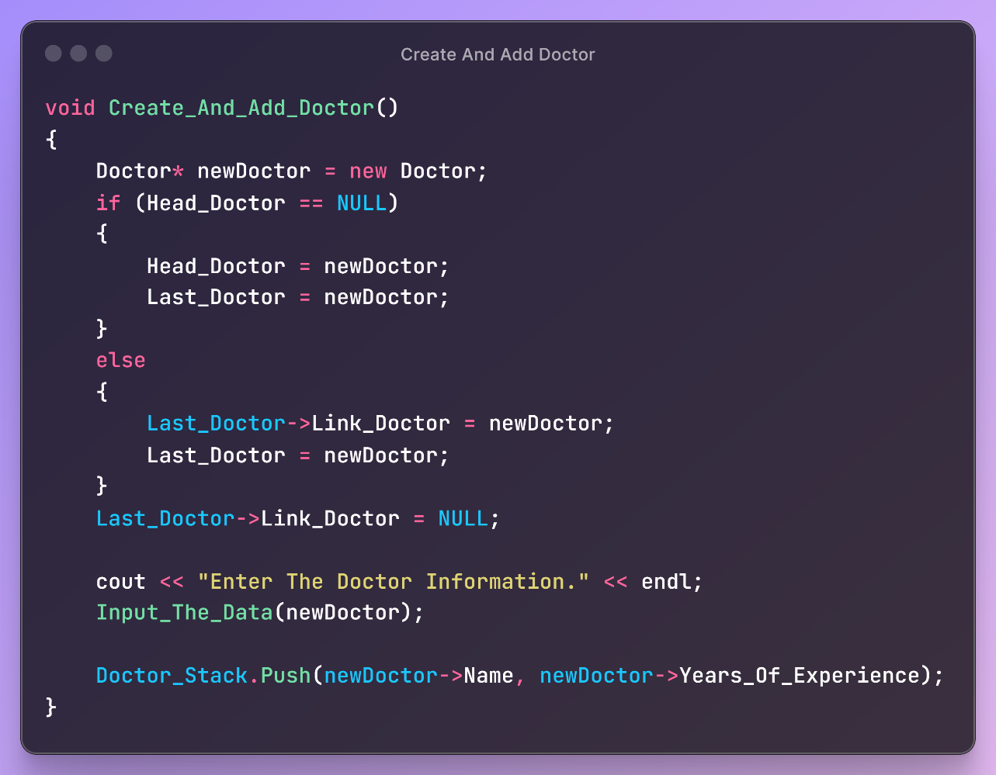

Figure 23 - Create and Add Doctor -

The Create_And_Add_Doctor function initializes a new Doctor object, adds it to a linked list, and pushes some of its details onto a stack. If the linked list is empty, both the Head_Doctor and Last_Doctor pointers are set to this new doctor. If not, the new doctor is added to the end of the list. The function ensures the new doctor's Link_Doctor pointer is set to NULL. After adding the doctor to the list, the function gathers the doctor's details through user input and pushes the doctor's name and years of experience onto a stack.

#### **3.5.2.3 - Input The Data**

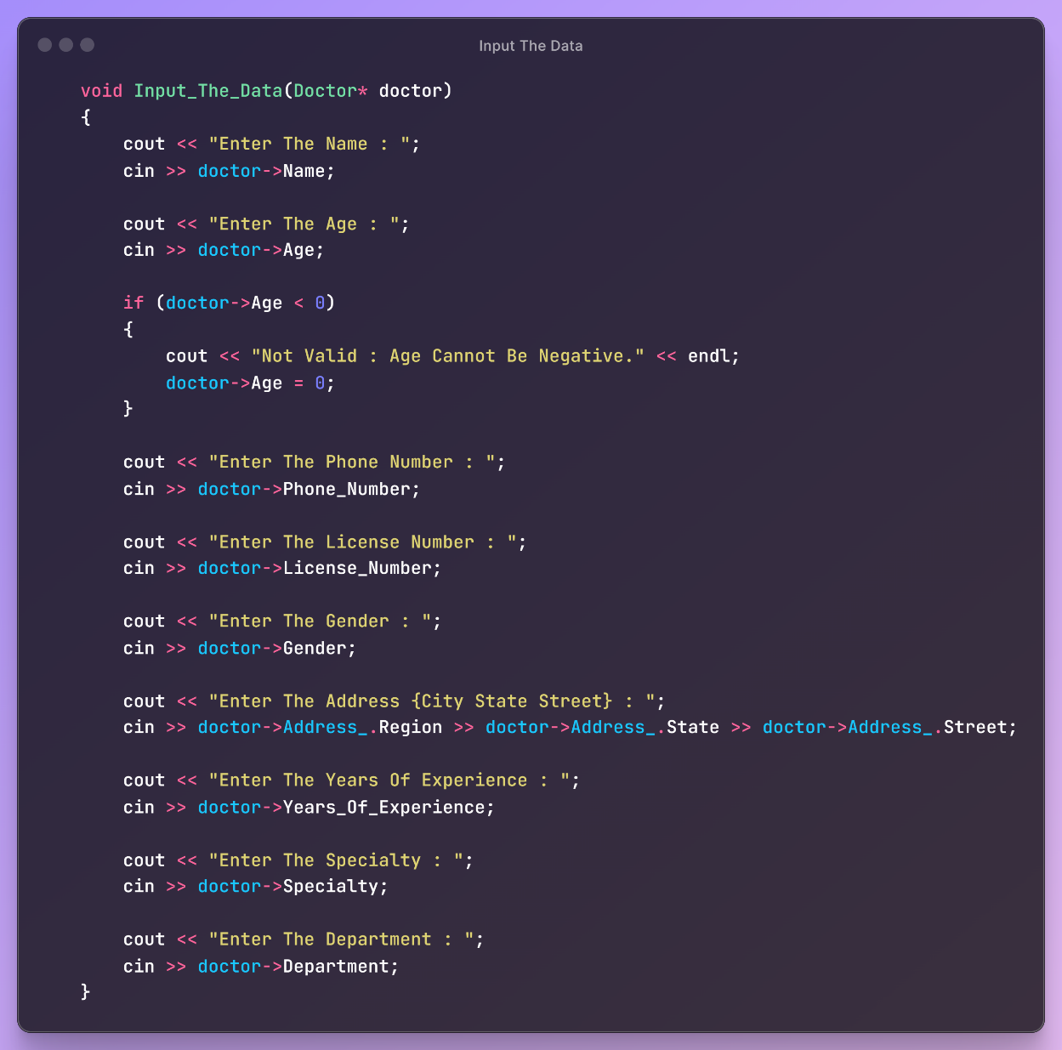

Figure 24 - Input the Data -

The Input_The_Data function collects and inputs details about a doctor from user input, ensuring proper data handling like setting negative ages to zero.

#### **3.5.2.4 - Print The Doctor List**

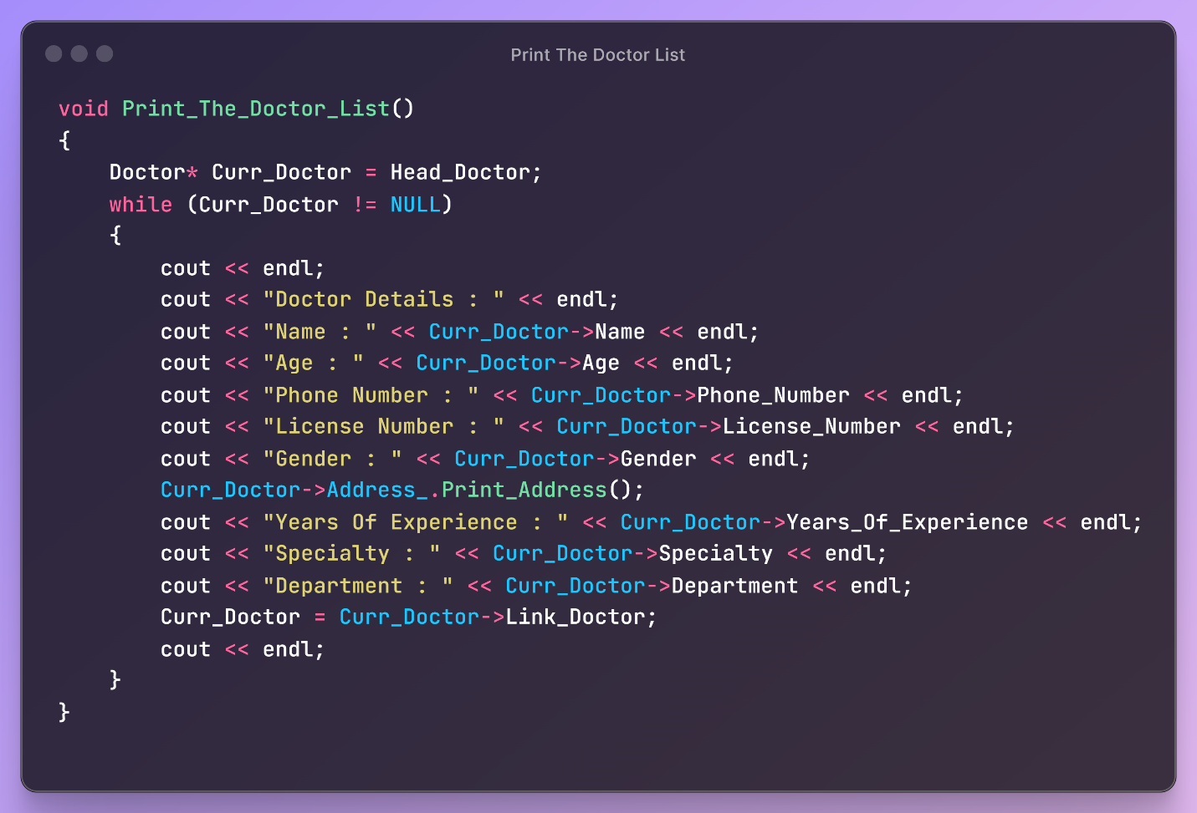

Figure 25 - Print Doctor List -

The Print_The_Doctor_List function traverses through a linked list of doctors, printing details such as name, age, and professional information for each doctor until the end of the list is reached.

#### **3.5.2.5 - Edit Doctor Information**

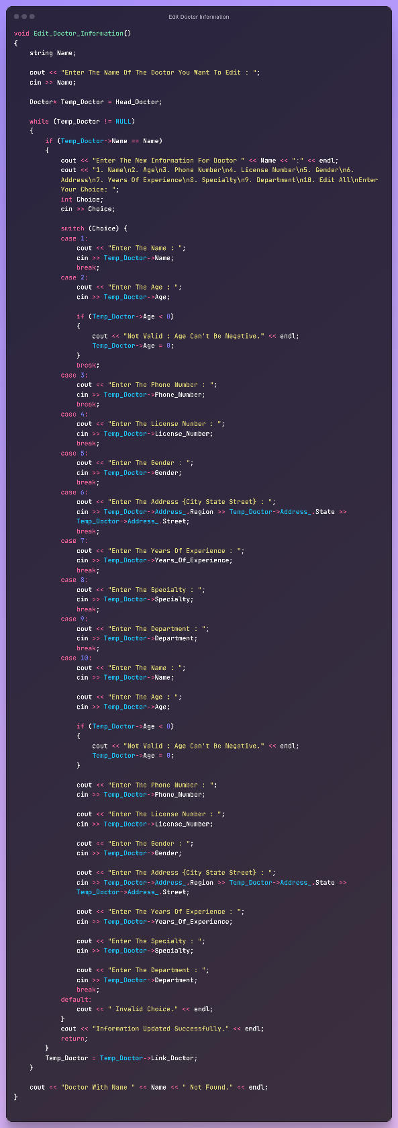The Edit_Doctor_Information function allows editing of a specified doctor's details from a linked list. Users enter the doctor's name, choose the detail to edit from a menu, and provide the new information. If the doctor is found, the information is updated; if not, a message indicates the doctor wasn't found.

Figure 26 - Edit Doctor Information -

\

#### **3.5.2.6 - Delete Doctor**

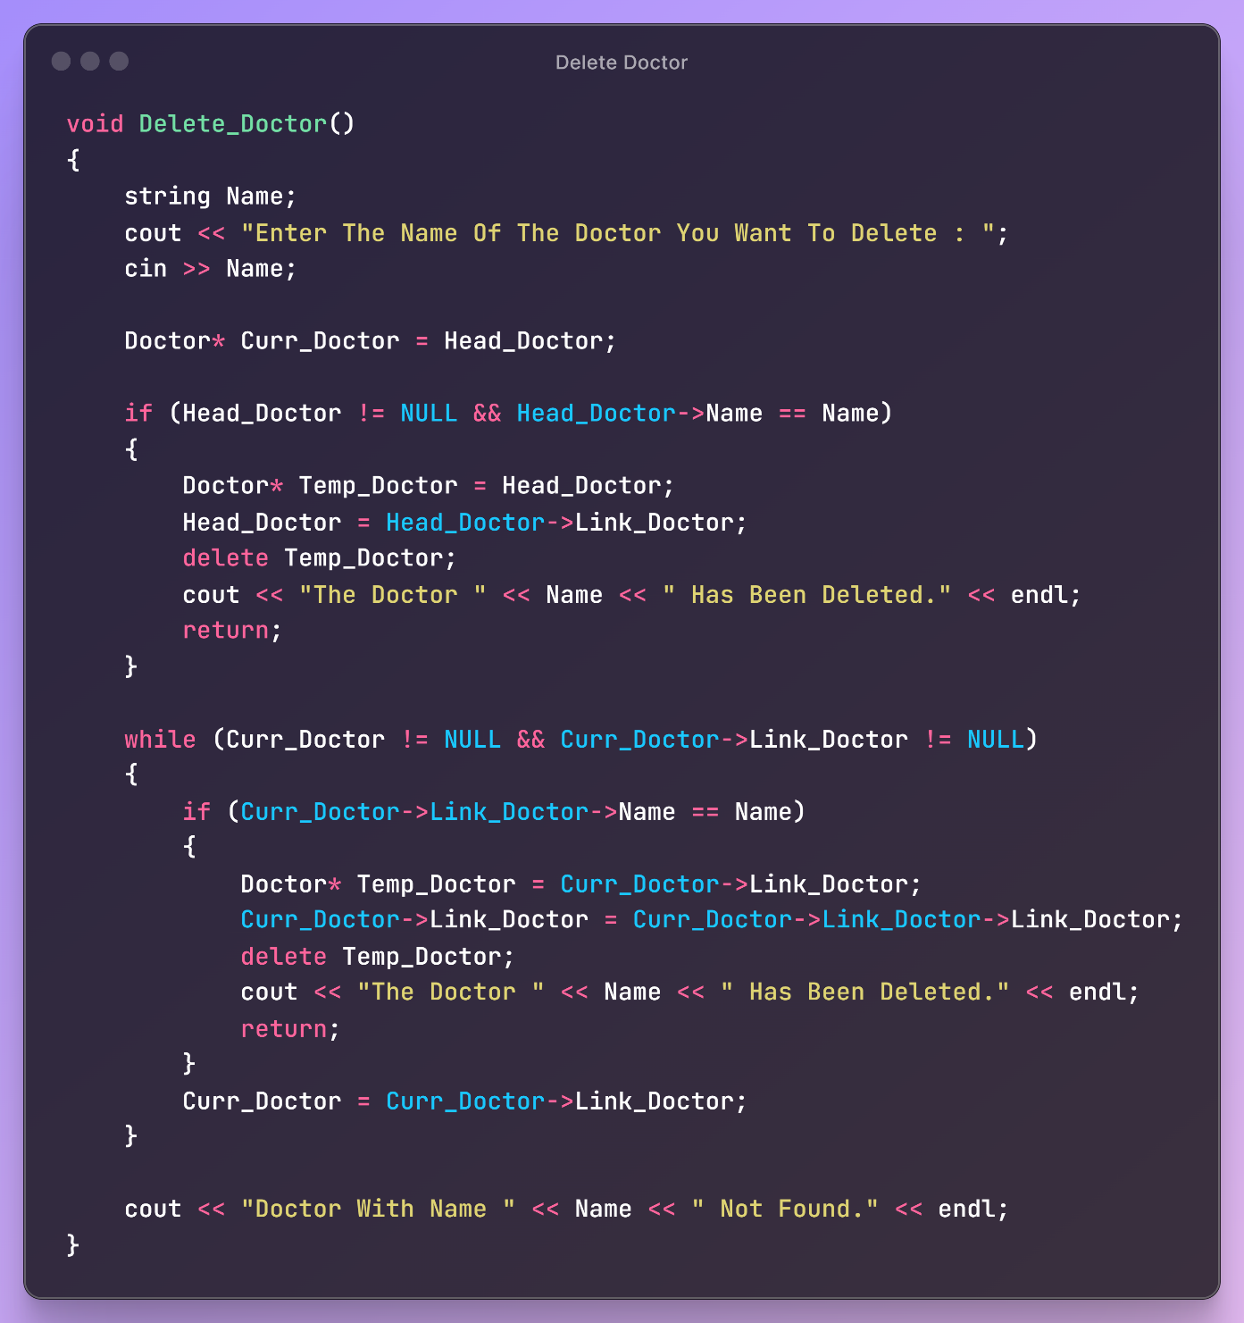

Figure 27 - Delete Doctor -

The Edit_Doctor_Information function allows editing of a specified doctor's details from a linked list. Users enter the doctor's name, choose the detail to edit from a menu, and provide the new information. If the doctor is found, the information is updated; if not, a message indicates the doctor wasn't found.

#### **3.5.2.7 - Print Doctor Stack**

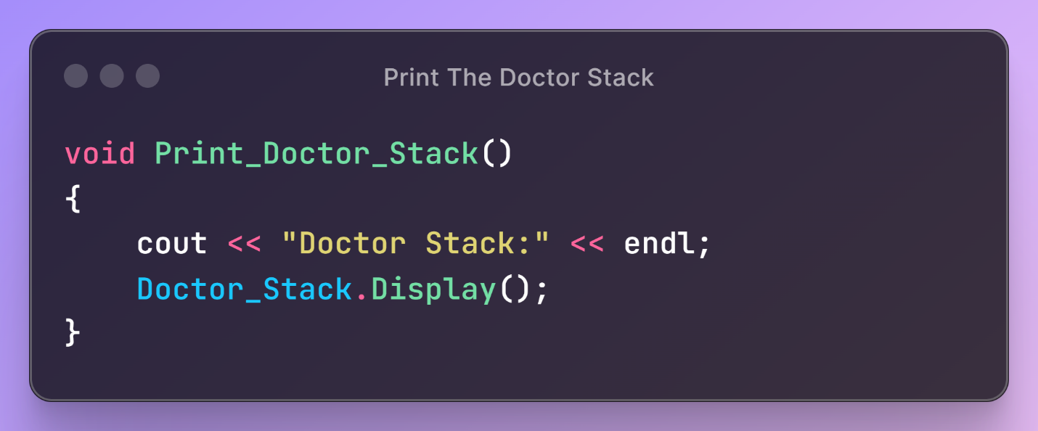

Figure 28 - Print Doctor Stack -

The Print_Doctor_Stack function prints the contents of a stack holding doctor information by calling the stack's Display method.

## **3.6 - Class Patient**

### **3.6.1 - Private**

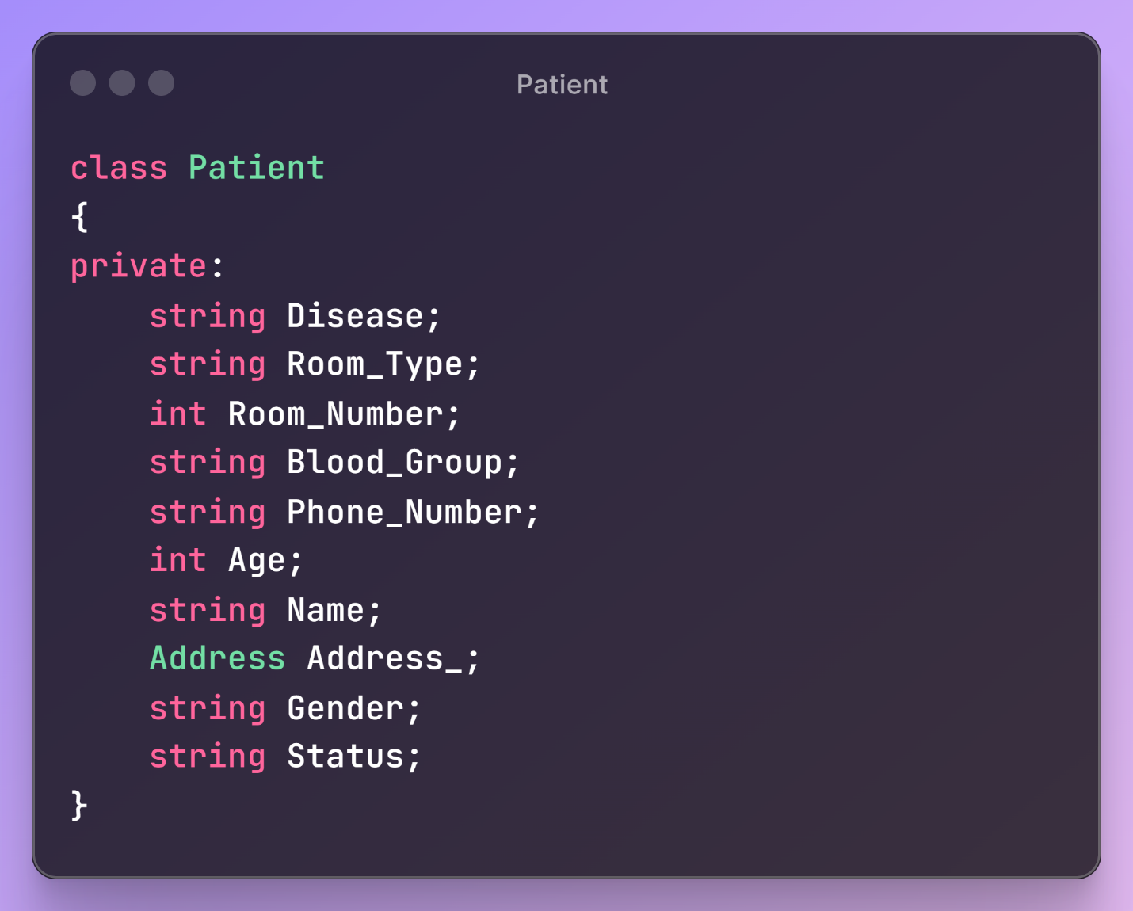

Figure 29 - Class Patient -

The Patient class has attributes for storing a patient's disease, room type and number, blood group, phone number, age, name, address, gender, and status.

### **3.6.2 - Public**

#### **3.6.2.1 - Pointers**

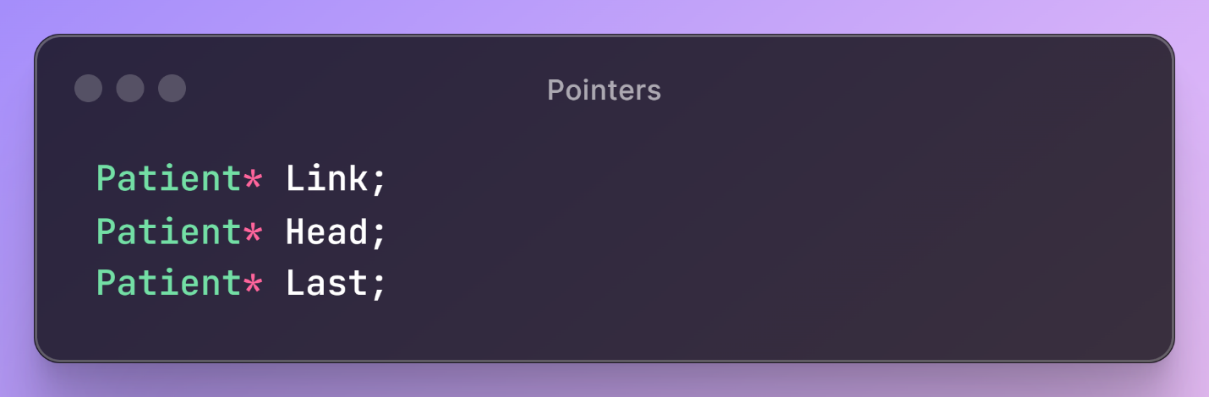

Figure 30 - Pointers -

The Patient class has three pointers used it to create the list

#### **3.6.2.2 - Constructor**

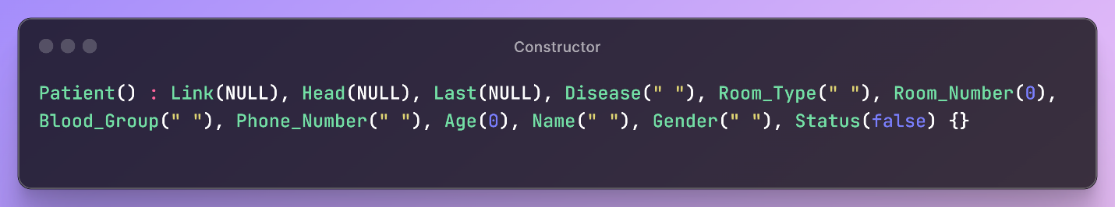

Figure 31 - Constructor -

The Patient constructor initializes all members to defaults: Link, Head, Last to NULL; Disease, Room_Type, Blood_Group, Phone_Number, Name, Gender, Status to empty strings; and Room_Number, Age to 0.

#### **3.6.2.3 - Create And Add Patient**

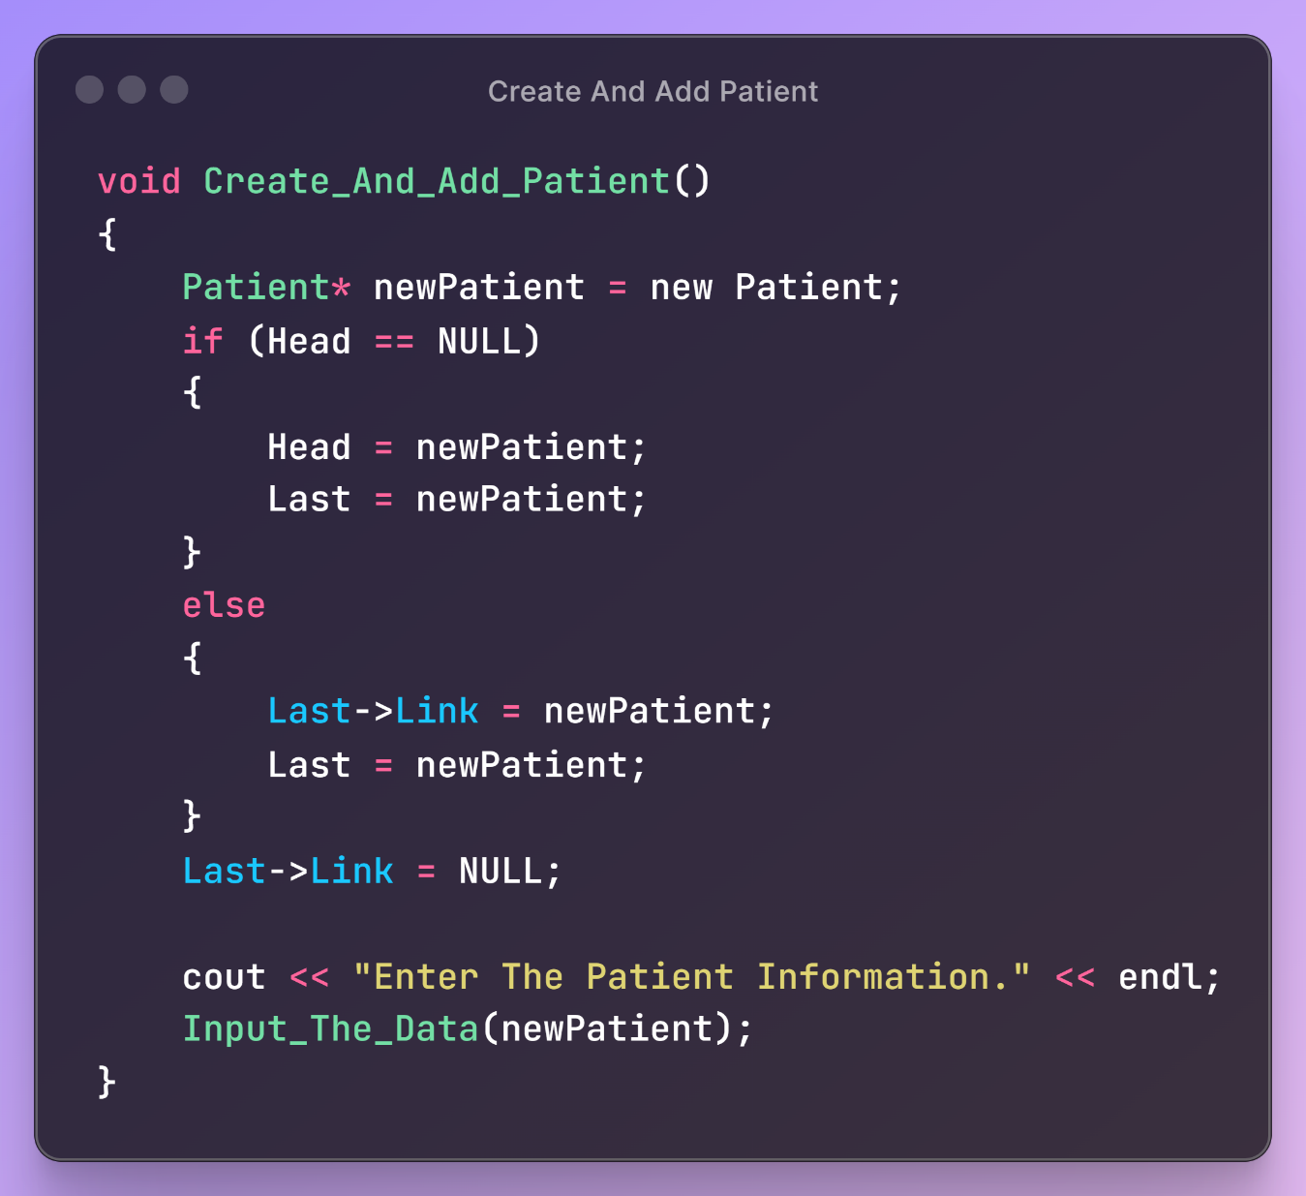

Figure 32 - Create and Add Patient -

The Create_And_Add_Patient function creates a new Patient. If the list is empty, it sets Head and Last to this patient. Otherwise, it links the current Last to the new patient and updates Last. Finally, it sets Last->Link to NULL and calls Input_The_Data.

#### **3.6.2.4 - Input The Data**

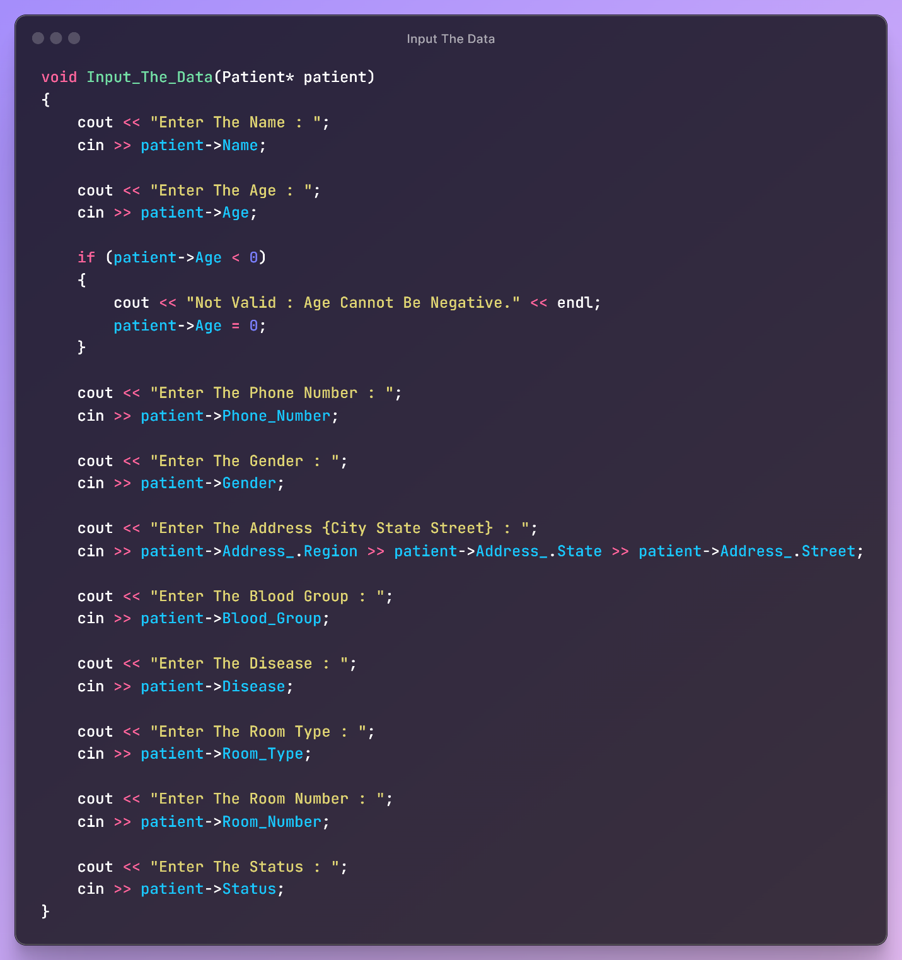

Figure 33 - Input the Data -

The function inputs the data using arrow.

#### **3.6.2.5 - Print The Patient List**

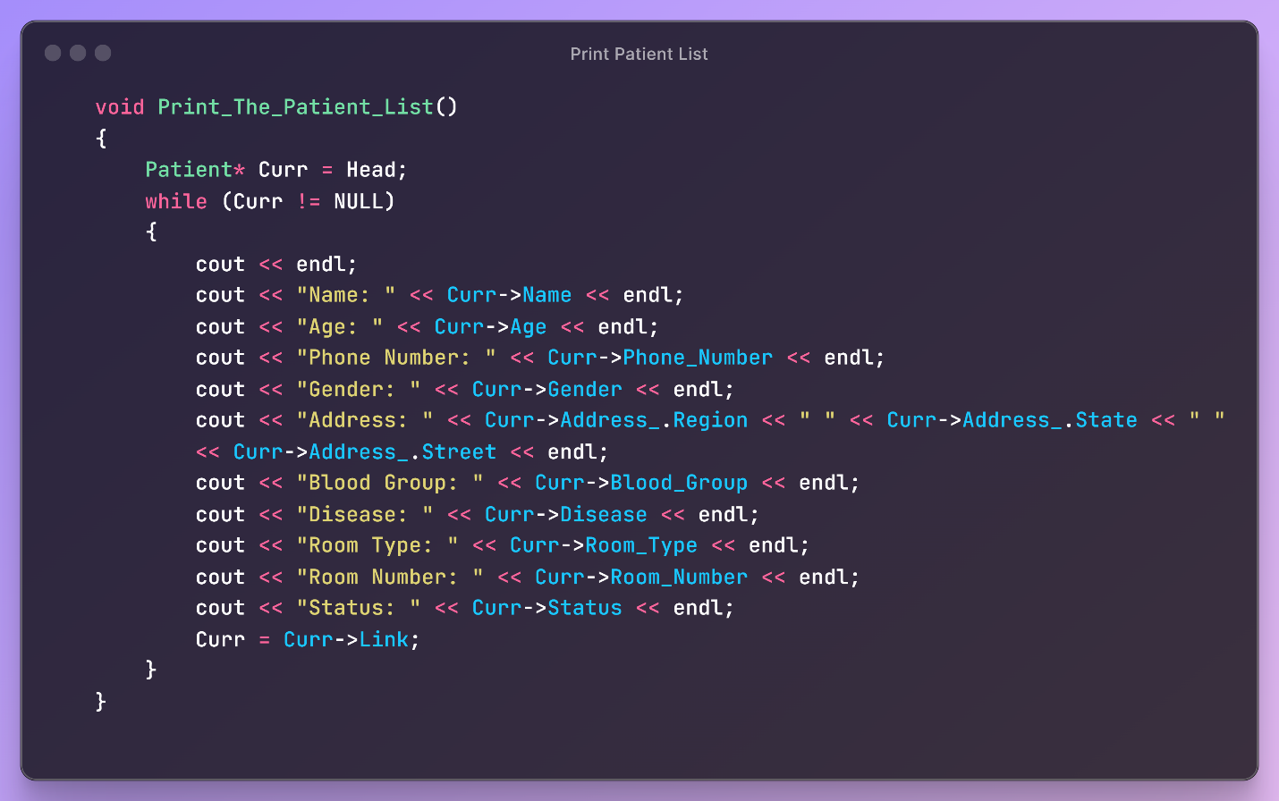

Figure 34 - Print List Patient -

The Print_The_Patient_List function traverses the linked list, printing each patient's details. It starts at Head and loops through each patient, printing Name, Age, Phone_Number, Gender, Address, Blood_Group, Disease, Room_Type, Room_Number, and Status. The loop ends when it reaches the end of the list (Curr is NULL).

#### **3.6.2.6 - Edit Patient List**

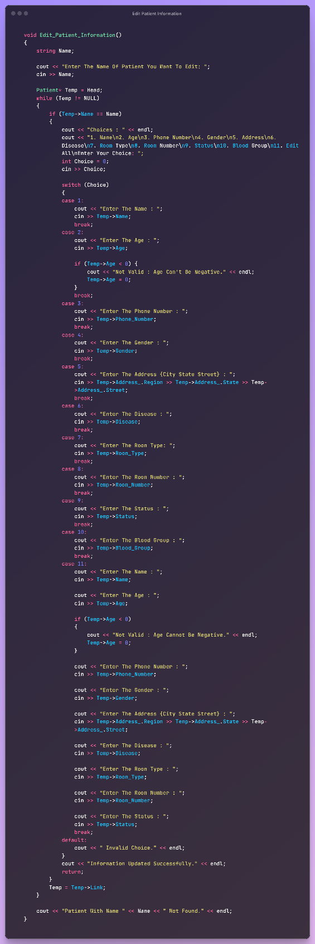

Figure 35 - Edit Patient Information -

The Edit_Patient_Information function lets the user modify a patient's details in the linked list. It prompts the user for the patient's name and searches the list from Head to find a match. If found, it shows a menu with options to edit attributes like name, age, phone number, gender, address, disease, room type, room number, status, blood group, or all information at once. The chosen attribute is updated, ensuring the age is non-negative. If the patient isn't found, a message is shown. The function ends by confirming the update was successful.

#### **3.6.2.7 - Delete Patient**

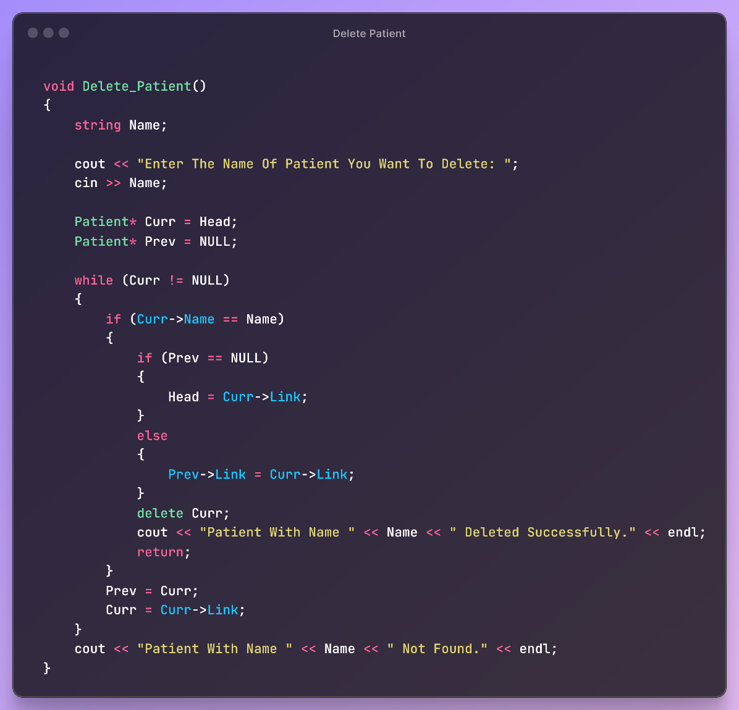

Figure 36 - Delete Patient -

The Delete_Patient function prompts for a name, searches the list, and removes the matching patient, updating links as needed. If found, it deletes the patient and confirms. If not found, it indicates this.

## **3.7 - Class Visitor**

### **3.7.1 - Private**

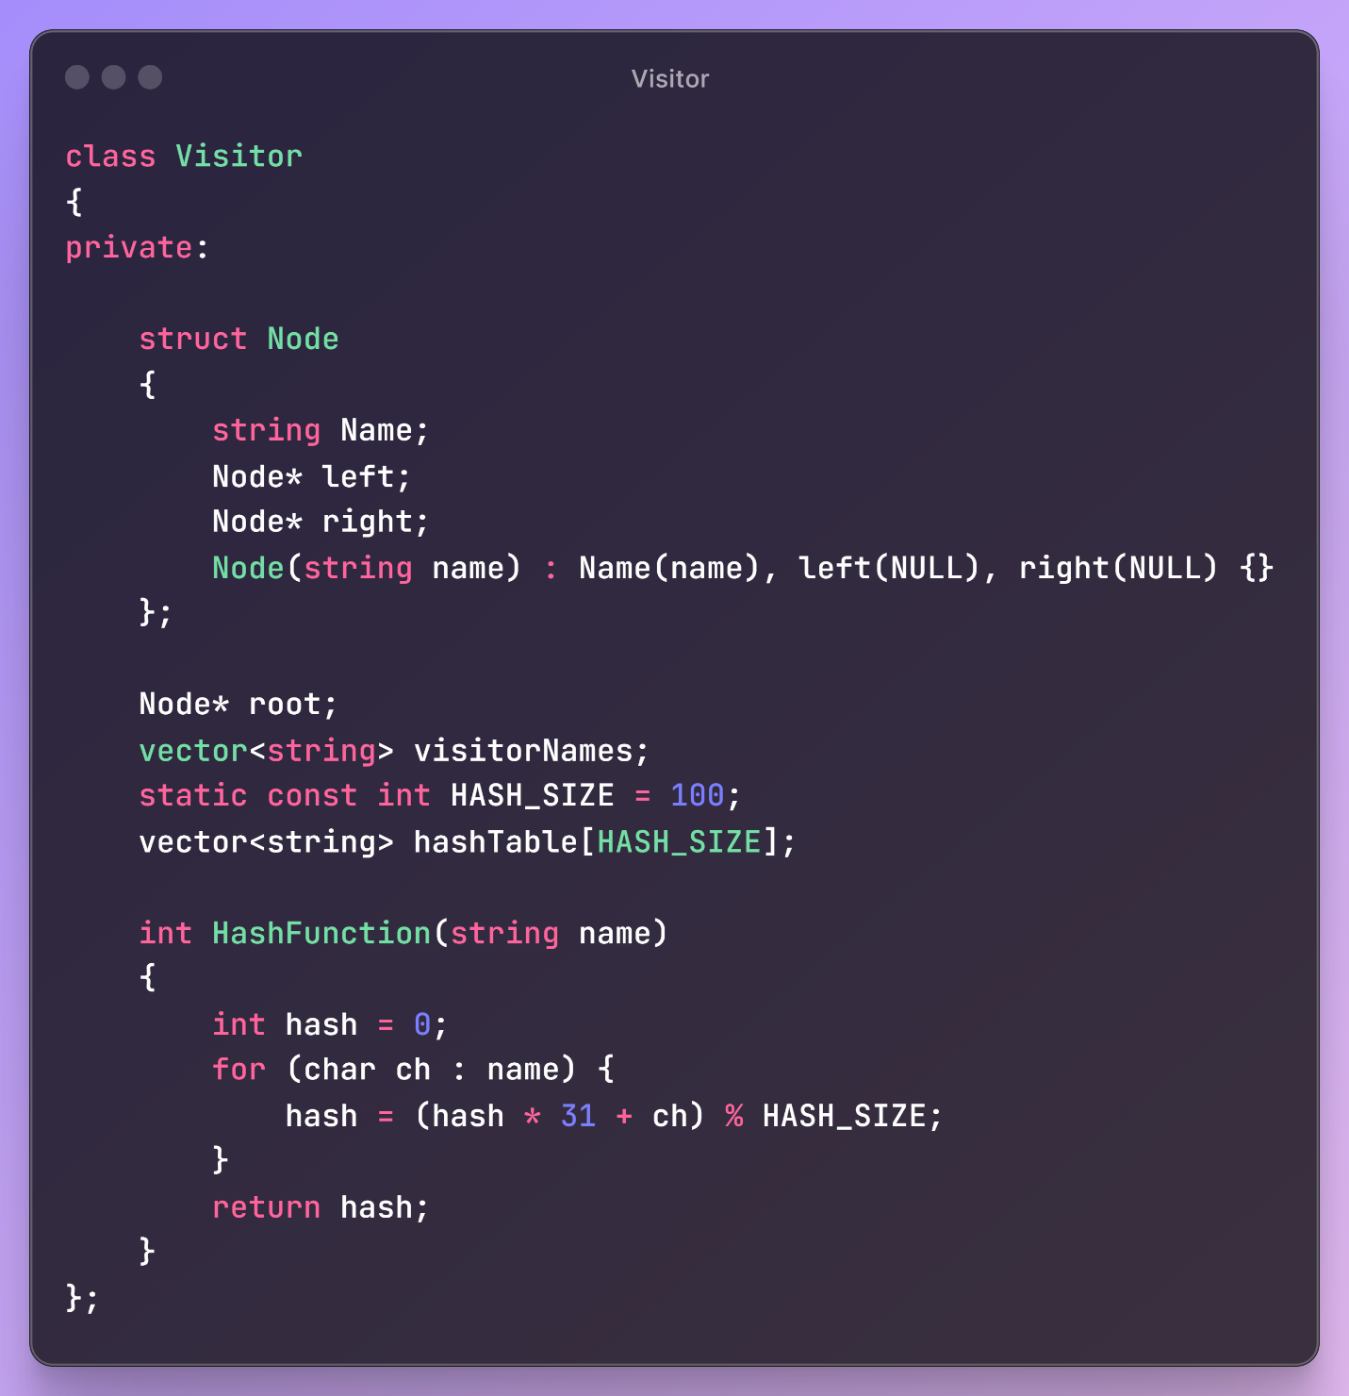

Figure 37 - Class Visitor -

The Visitor class uses a binary search tree (BST) and a hash table to efficiently manage and retrieve visitor names. It includes a private Node structure representing each BST node, storing a name and pointers to left and right children. The class has a root pointer for the BST, a vector for storing all visitor names, and a hash table with a size of 100, implemented as an array of vectors to handle collisions. The HashFunction method computes a hash value for each name by processing each character and applying a modulus operation to fit within the hash table size, ensuring efficient and quick lookups.

### **3.7.2 Public**

#### **3.7.2.1 - Constructor**

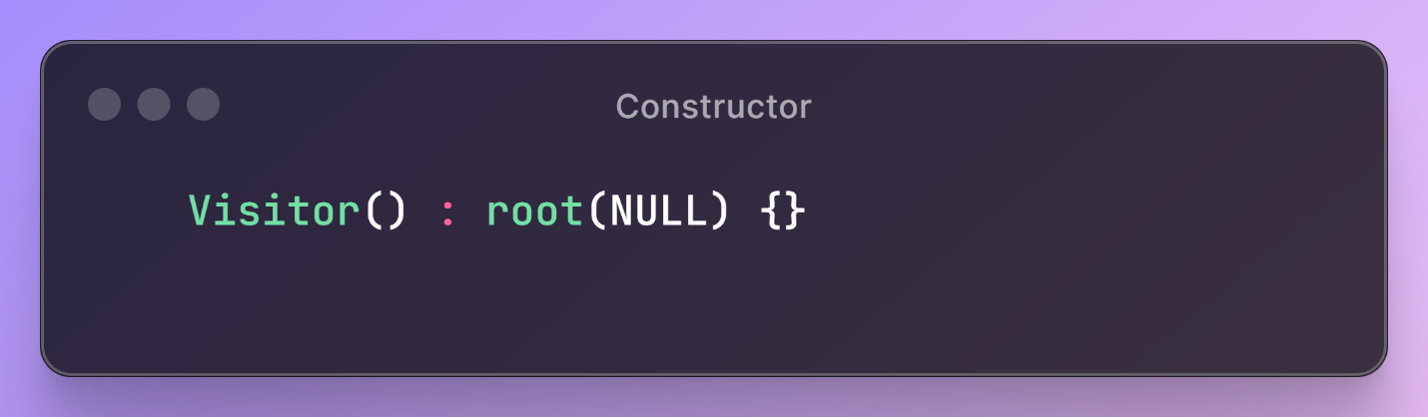

Figure 38 - Constructor -

#### **3.7.2.2 - Insert**

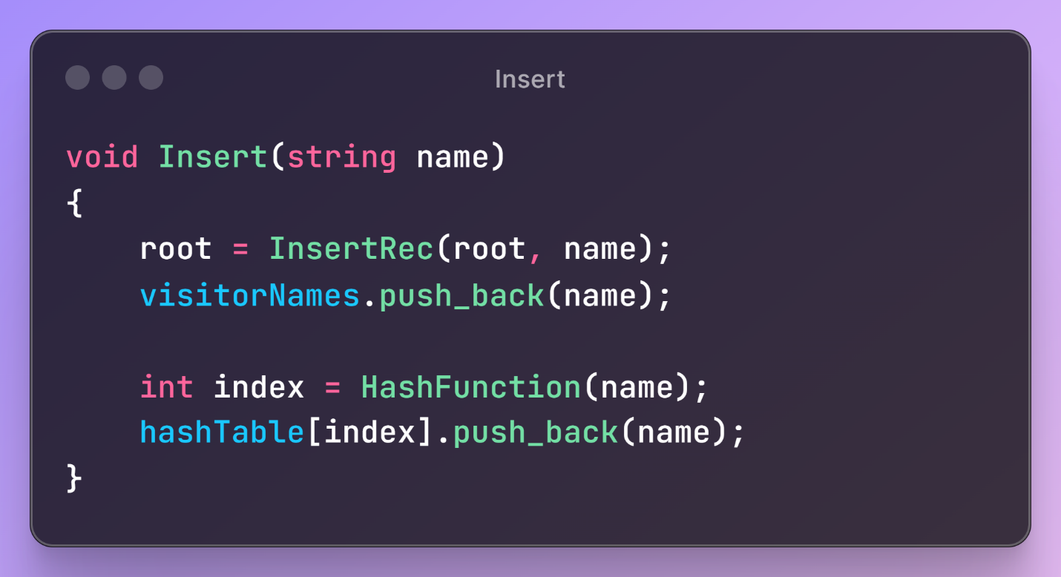

Figure 39 - Insert -

The Insert function ensures that the visitor's name is added to both the BST and the hash table, allowing efficient lookups using either data structure. The BST provides ordered storage and fast lookups, while the hash table allows for quick direct access based on the hash value.

#### **3.7.2.3 - InsertRec**

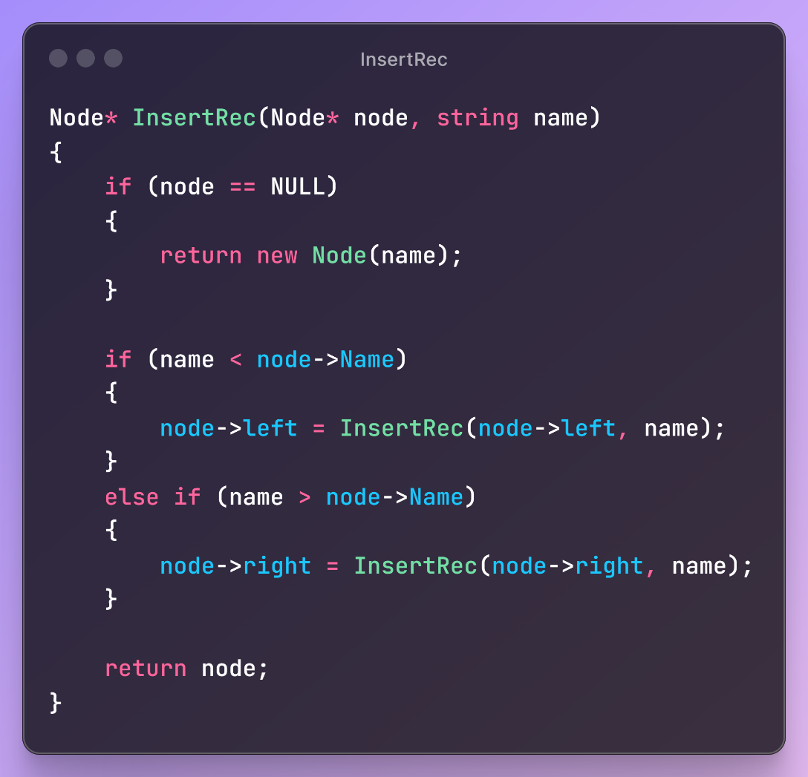

Figure 40 - InsertRec -

InsertRec traverses the tree to find the appropriate position for the new node. If the tree is empty at the position, it inserts the new node. Otherwise, it recursively moves left or right, maintaining the binary search tree property where the left child contains nodes with names less than the parent node, and the right child contains nodes with names greater than the parent node.

#### **3.7.2.4 - Printing Functions**

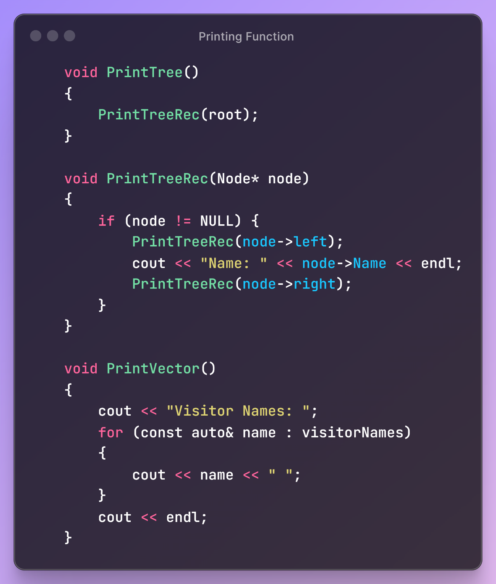

Figure 41- Printing Function -

The function prints the tree, treerec and vector.

#### **3.7.2.5 - Retrieve Method**

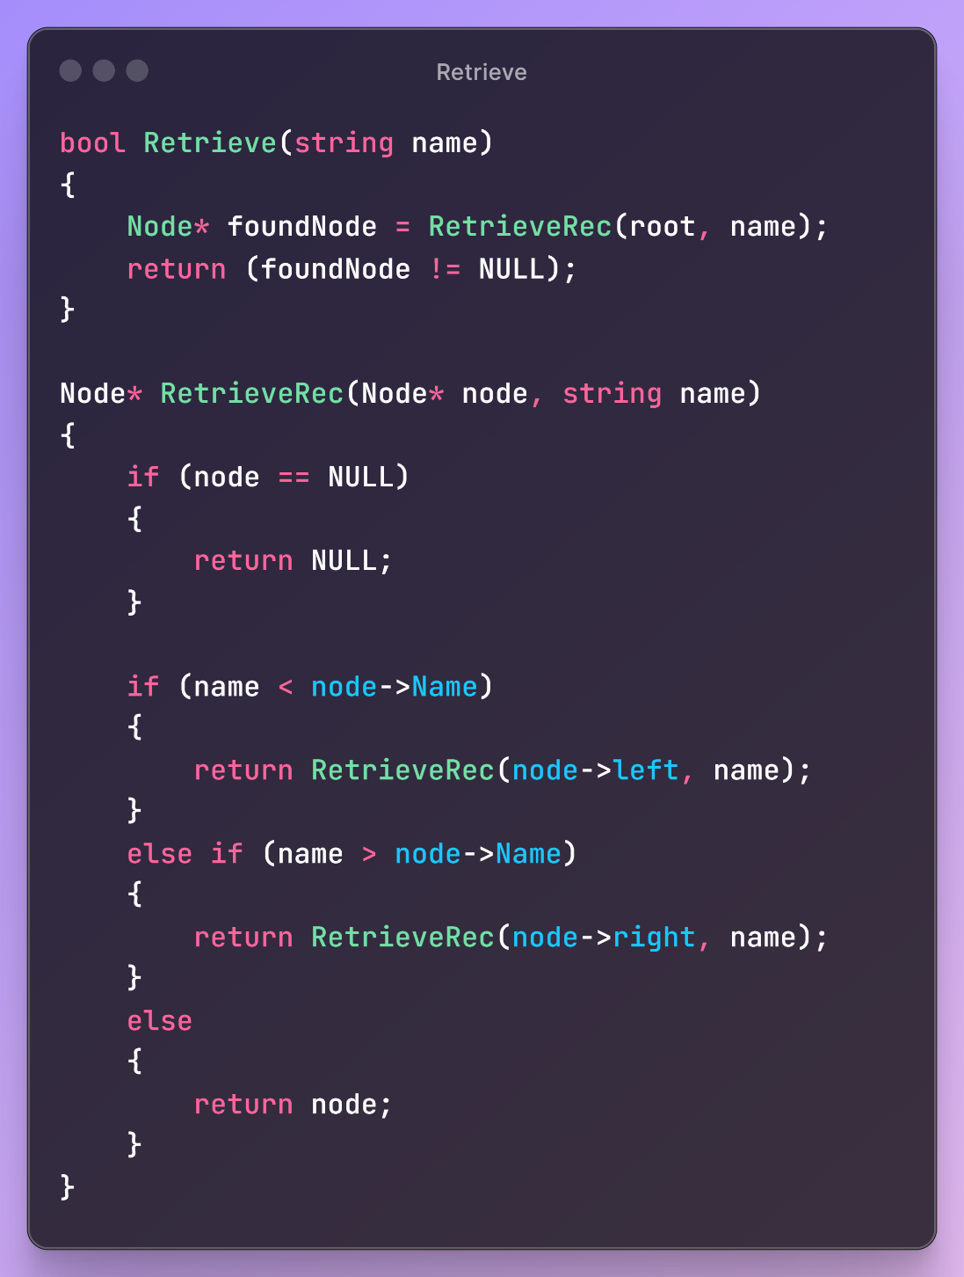

Figure 42 - Retrieve Method -

The Retrieve function starts the search for a node with the given name, and the RetrieveRec function performs the actual search recursively. It traverses the tree, moving left if the target name is less than the current node's name, and moving right if the target name is greater. If it finds the node with the matching name, it returns that node; otherwise, it returns NULL. The Retrieve function then checks if the returned node is NULL to determine if the name was found in the tree.

#### **3.7.2.5 - Print Hash Table**

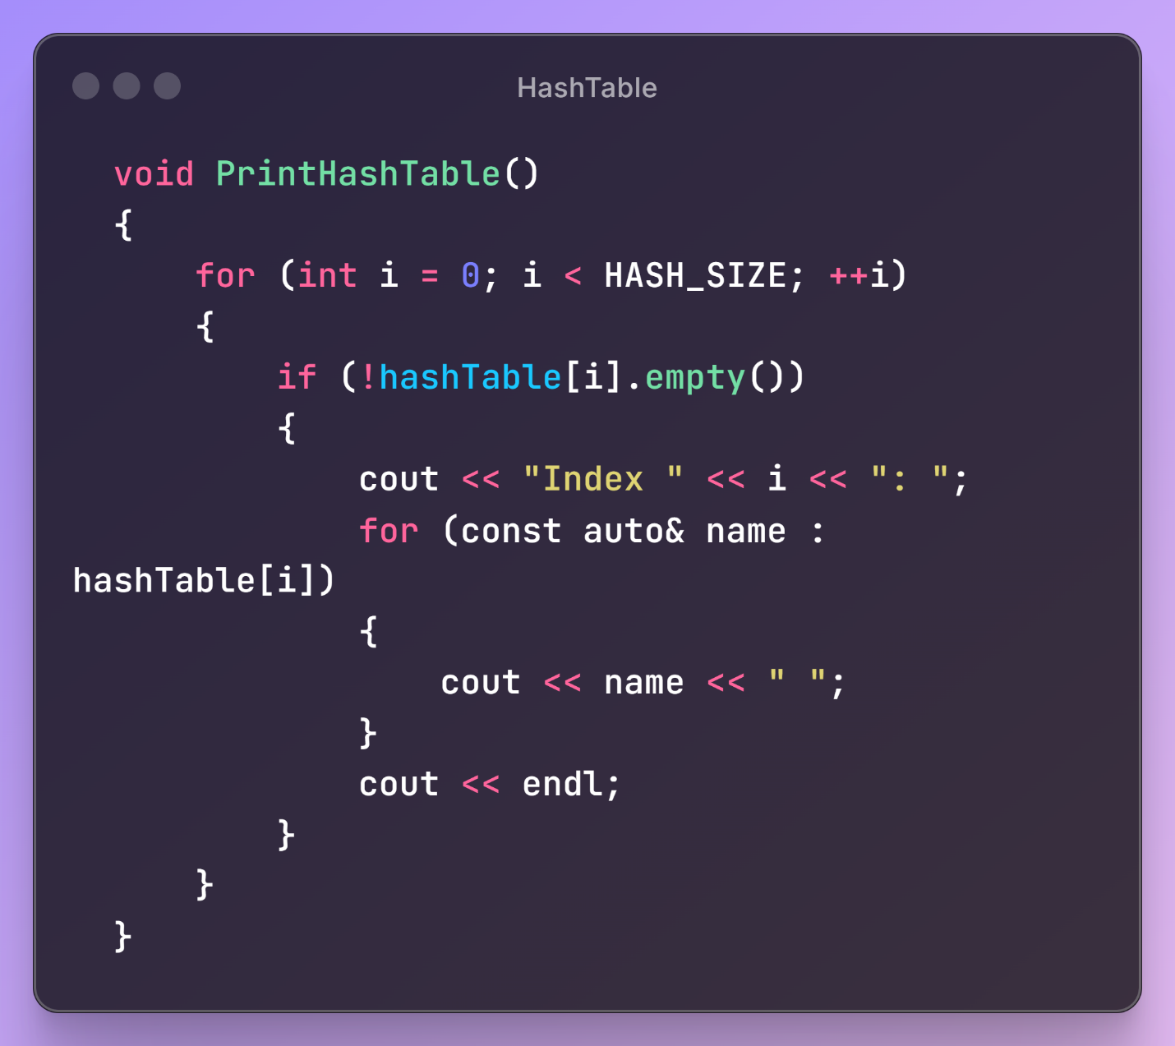

Figure 43 - Print Hash Table -

The function will print the table after hashing in array.

## **3.8 - Binary Search**

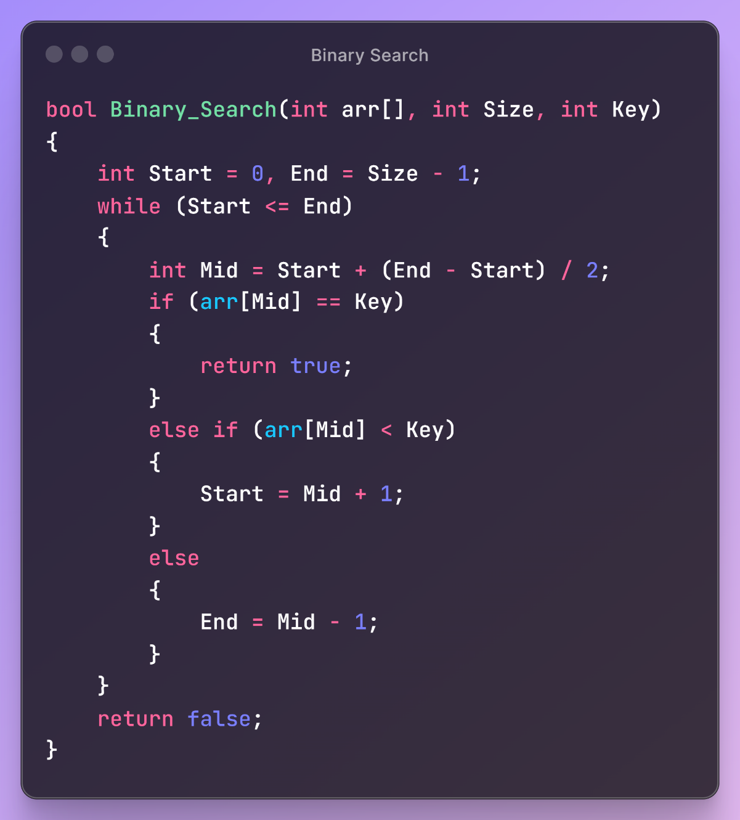

Figure 44 - Binary Search -

The Binary_Search function is a classic implementation of the binary search algorithm. It searches for a specific key in a sorted array.

## **Conclusion**

This project demonstrates a comprehensive system for managing various aspects of hospital operations using multiple data structures. The system incorporates linked lists for managing lists of nurses, doctors, and patients, ensuring efficient addition, deletion, and modification of records. It also includes a binary search tree (BST) for organizing visitor information, and a hash table for fast lookups of visitor names, showcasing the use of hashing for quick data retrieval. Additionally, the project features a stack to handle doctor data in a LIFO (Last In, First Out) manner, and a queue for managing emergency patient cases in a FIFO (First In, First Out) order. By combining these data structures, the project effectively handles complex data management tasks, demonstrating the importance and utility of data structures in developing robust and scalable applications. The inclusion of user interaction through a menu-driven interface further highlights the practical implementation of these data structures in real-world scenarios.